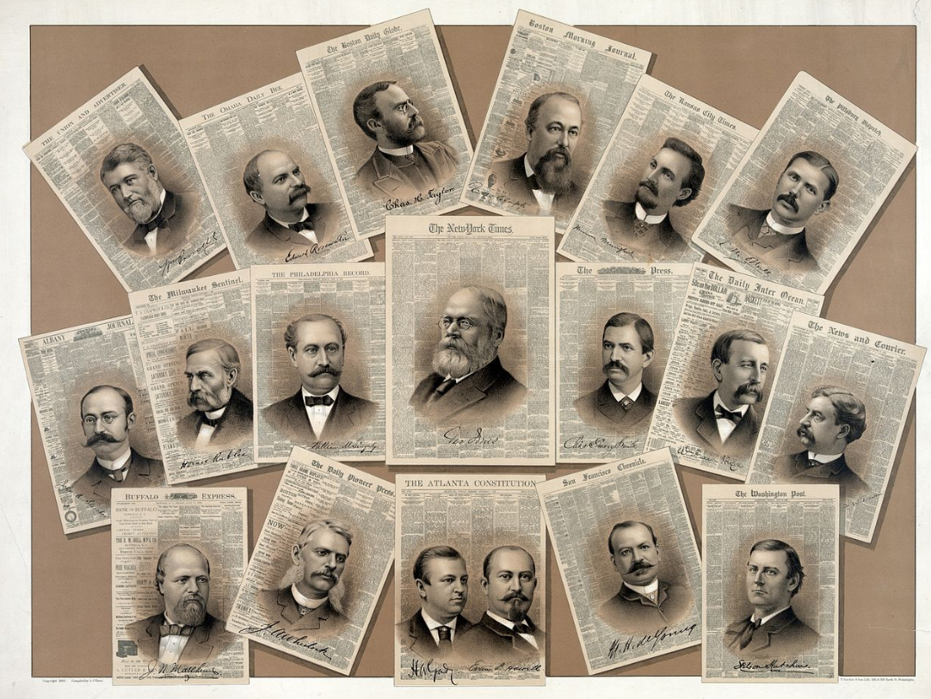

Fallout 4: The Rise of the Best Journalist
  - Version 1.0
Designer: | Yan Zhang
Document Date: | 05/27/2020
Intended Level Delivery Date: | 07/21/2020

Document Revisions Table
Version | Description | Requestor | Date
1.0 | Initial Document | Professor Skinner | 05/27/2020
2.0 | Final Version | Professor Skinner | 07/12/2020

Table of Contents
Table of Contents 2
Table of Figures 4
Level Information 5
Quick Summary 5
Level Map(s) 6
The Journey in Commonwealth 8
Spot 1 – Mutant Hounds’ Threat 9
Spot 2 – Feral Ghouls’ Threat 11
Spot 3 – Westing Estate 13
Spot 4 – Abandoned Houses 15
Hidden Basement 17
Sebsequent Quest – New Home: Diamond City (Ending 1) 19
Sebsequent Quest – New Home: Goodneighbor (Ending 2) 20
Sebsequent Quest – New Home: Sanctuary (Ending 3) 21
Ending 4 22
Objective(s) 22
Hook(s)/Gameplay Highlights 22
Campaign 22
Context 22
Backstory 23
Aftermath 23
Development Schedule 23
Key Theme References 24
Oliver Trace’s Office 24
Abandoned Cabin 24
Hidden Basement 25
Immigration Office 25
Requirements 26
Appendix A: Quest Summary 27
Main Quest 27
Appendix B: Main Characters 30
Oliver Trace 30
Pam Johns 30
Rick 30
Saul Checker 30
Appendix C: Dialogue Flow 31
Oliver Trace 31
References 33

Table of Figures

Figure 1: Oliver Trace's office - Exterior 5
Figure 2: Oliver Traces' Office - Interior 5
Figure 3: The Journey in the Commonwealth 7
Figure 4: First Turn to Spot 1 8
Figure 5: Screenshot of Spot 1 8
Figure 6: Top-down Map of Spot 1 9
Figure 7: Screenshot of Spot 2 10
Figure 8: Top-down Map of Spot 2 11
Figure 9: Screenshot of Spot 3 12
Figure 10: Screenshot of the Bridge to Spot 4 12
Figure 11: Top-down Map of Spot 3 13
Figure 12: Screenshot of Spot 4 14
Figure 13: Top-down Map of Spot 4 15
Figure 14: Hidden Basement 16
Figure 15: Diamond City Immigration Office - Exterior 18
Figure 16: Top-down Map of Diamond City Immigration Office 18
Figure 17: Screenshot of Daisy's Store 19
Figure 18: Screenshot of Sanctuary 20
Figure 19: Contact Sheet for Oliver’s Office [1][2][3][4] 23
Figure 20: Contact Sheet for Abandoned Cabin [5][6][7][8] 23
Figure 21: Contact Sheet for Hidden Basement [9][10][11][12] 24
Figure 22: Contact Sheet for Immigration Office [13][14][15][16] 24

Level Design Document

Level Information

Quick Summary
“The Rise of the Best Journalist” is a series of standalone quests for Fallout 4. This series contains four quests “The Exclusive Report”, “New Home: Diamond City”, “New Home: Goodneighbor” and “New Home: Sanctuary”, which are set after the player completes the main quest “Getting a Clue”.
The quest starts in Diamond City when the player meets Oliver Trace, a novice journalist, who asks the player’s help to complete a special interview. The quest combines NPC interactions, story-telling and combats. The player will meet a vivid non-combat companion and several believable NPCs whose fates are decided by the player’s choice.

Level Map(s)
Oliver Trace’s Office - Entrance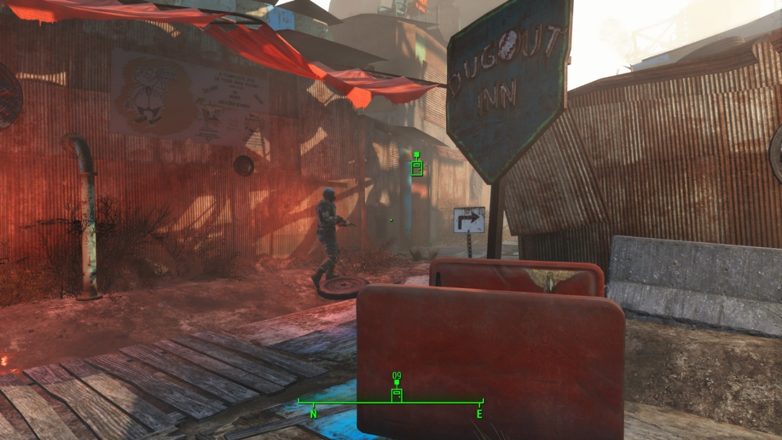

1
Figure 1: Oliver Trace's office - Exterior
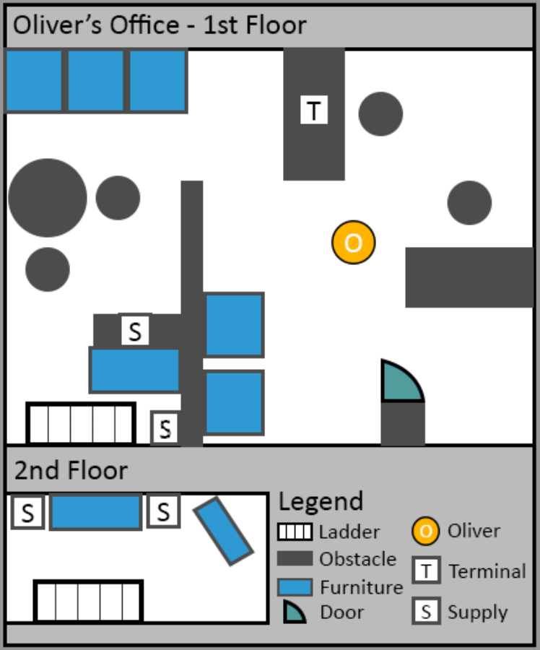

2

3
Figure 2: Oliver Traces' Office - Interior
Map Label | Objective/Simple Action Summary | Challenge/Conveyance Details | NPC Interactions | Difficulty (1-10)
1 | Enter Diamond City and find Oliver Trace’s Office | - The player enters Diamond City and when he goes down the stairs, the quest pops out automatically.  - The player can find Oliver’s office on the opposite side of Dugout Inn. | - None | 1
2 | Enter Oliver’s Office and start an interview | - Oliver talks to the player after his entering the office.  - Start an interview first and then talk about the quest Oliver would like to give. | - Normal Dialogue  - Idle animation during the conversation  - Start to lead the way | 1
3 | A terminal containing Oliver’s interview plan | - The players can check Oliver’s interview plan in this terminal and get some background information. | - None | 1

The Journey in Commonwealth
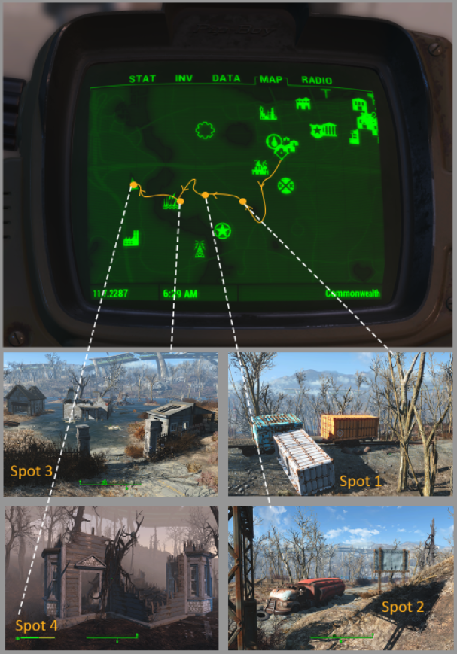

7

6

5

4
Figure 3: The Journey in the Commonwealth
The player needs to protect Oliver during his journey of following the markers he made before to find his interviewee, Pamin the Commonwealth. The journey requires the player to pass 4 spots and finally gets to a secret basement in a woods. Oliver can’t help directly in combat since he is afraid of blood but he can offer warnings and supplies to the player.

Spot 1 – Mutant Hounds’ Threat
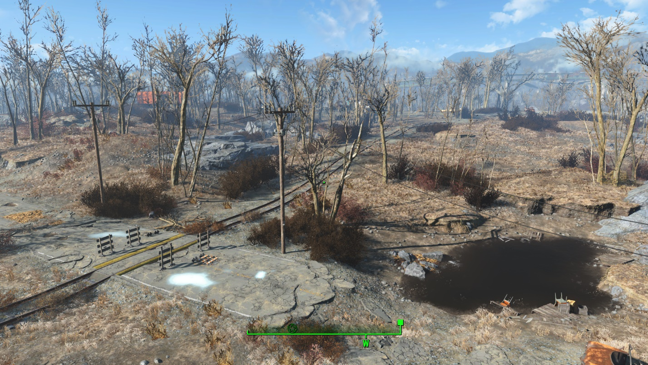

4-1
Figure 4: First Turn to Spot 1
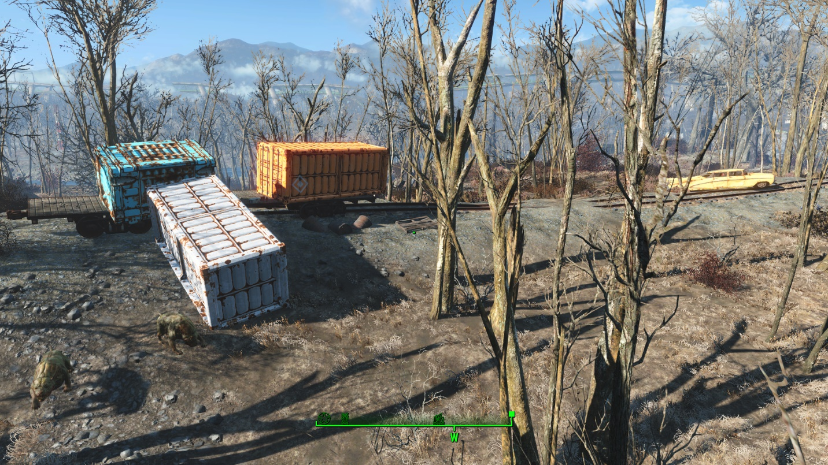

4-4

4-3

4-2
Figure 5: Screenshot of Spot 1
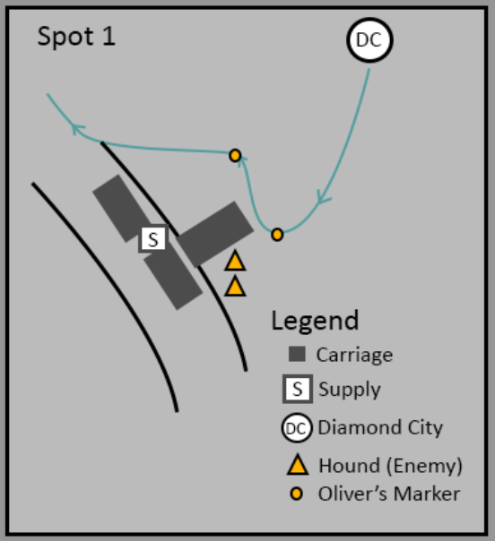

4-4

4-3

4-2
Figure 6: Top-down Map of Spot 1
Map Label | Event Description | Detail Information | NPC Interactions | Difficulty (1-10)
4-1 | Oliver leads the player to the railway and turns right | - The player meets Oliver at the entrance of Diamond City and he leads the player to find the first marker.  - After reaching the railway, Oliver tells the player to turn right. | - Lead the way  - Talking during leading | 2
4-2 | Oliver arrives at Spot 1 but finds two hounds there. | - Two mutant hounds are wandering near Spot 1. Oliver runs away immediately when meeting them.  - The player can choose fight with the hounds or not. | - Lead the way  - Talking during leading  - Early warn the coming threat  - Idle shift  - Combat performance (run away) | 4
4-3 | The player needs to talk to Oliver who is waiting near a tree to continue the quest. | - Oliver is waiting near a tree to avoid combats. He tries to comfort himself at that moment.  - The player needs to talk to him, then the journey continues. | - Lead the way  - Idle shift  - Combat performance (hide in a certain spot) | 2
4-4 | Some supplies | - The player can get some purified water and stimpaks there. | - None | 2

Spot 2 – Feral Ghouls’ Threat
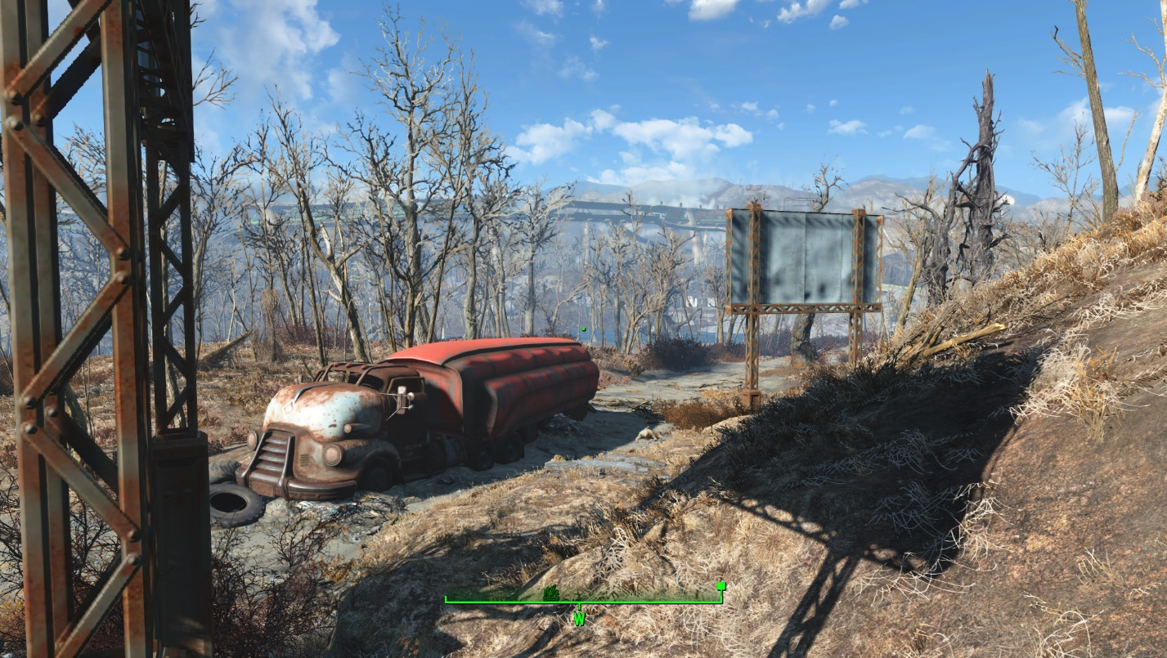

5-3

5-2

5-1
Figure 7: Screenshot of Spot 2
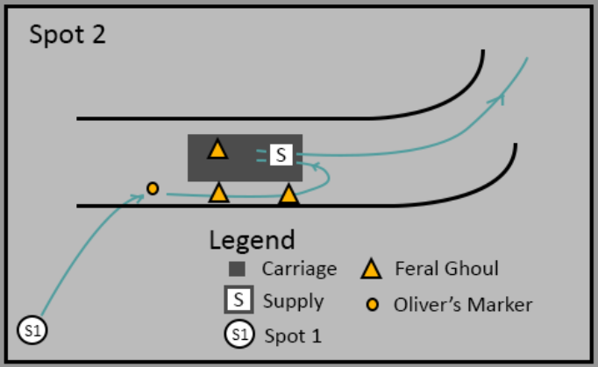

5-3

5-2

5-1
Figure 8: Top-down Map of Spot 2
Map Label | Event Description | Detail Information | NPC Interactions | Difficulty (1-10)
5-1 | Oliver leads the player to the second marker and stops in front of a truck. | - The second marker is left near a truck carriage.  - Oliver warns the player the dead bodies near the truck.  - He also mentions the supplies in the truck.  - He asks the player to clear the path for him and he will wait until it’s done. | - Lead the way  - Talking during leading  - Idle shift  - Combat performance (hiding in a certain spot)  - Personal comments on the ambushing ghouls. | 2
5-2 | Two feral ghouls’ ambush | - When the player comes close to the carriage, two ghouls wake up and attack the player. | - Wait at a certain spot | 4
5-3 | One feral ghoul hiding behind crates starts its ambush. | - When the player enters the carriage and gets close to the supply bag, another ghoul will appear and start a fight.  - After dealing with all the three ghouls, the player needs to go back to talk to Oliver and continues the quest. | - Wait at a certain spot  - Normal dialogue | 4

Spot 3 – Westing Estate
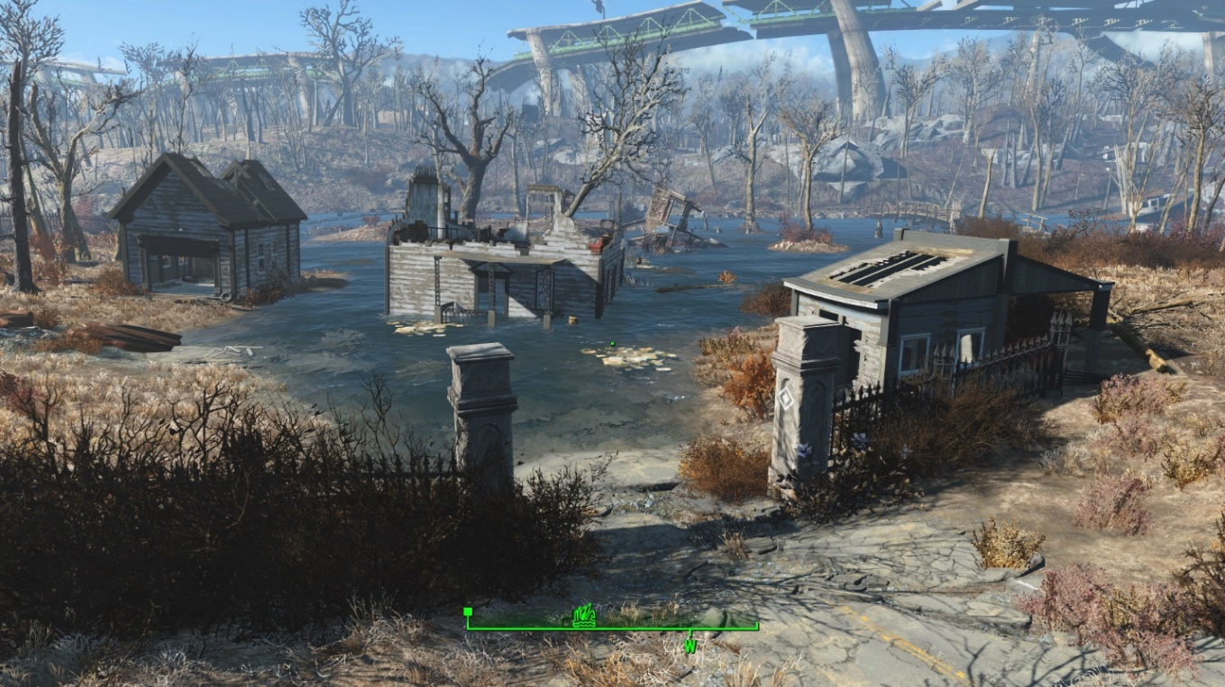

6-4

6-3

6-2

6-1
Figure 9: Screenshot of Spot 3
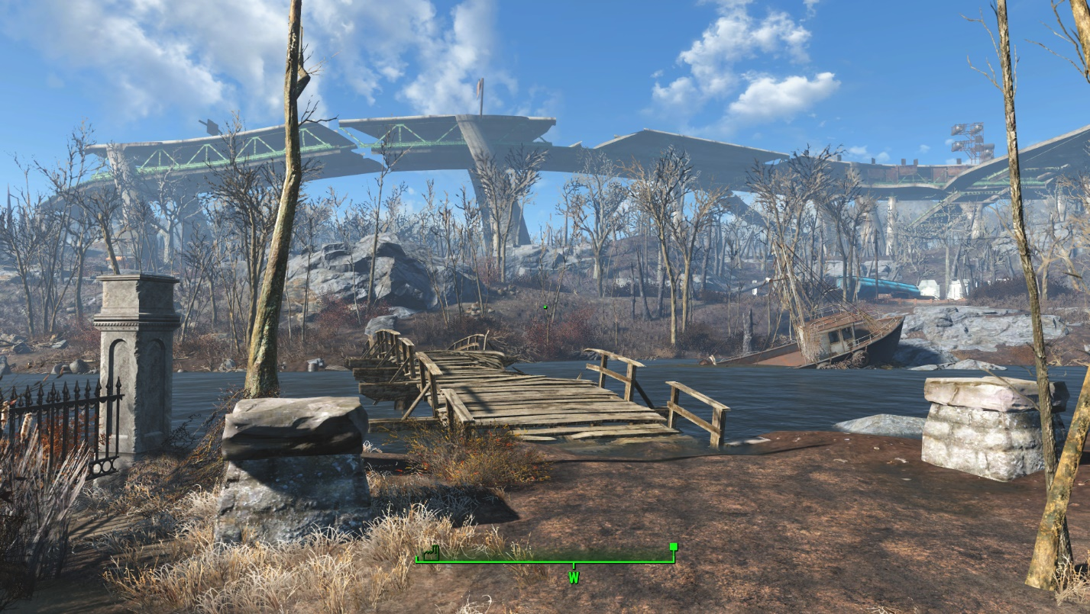

6-4

6-3
Figure 10: Screenshot of the Bridge to Spot 4
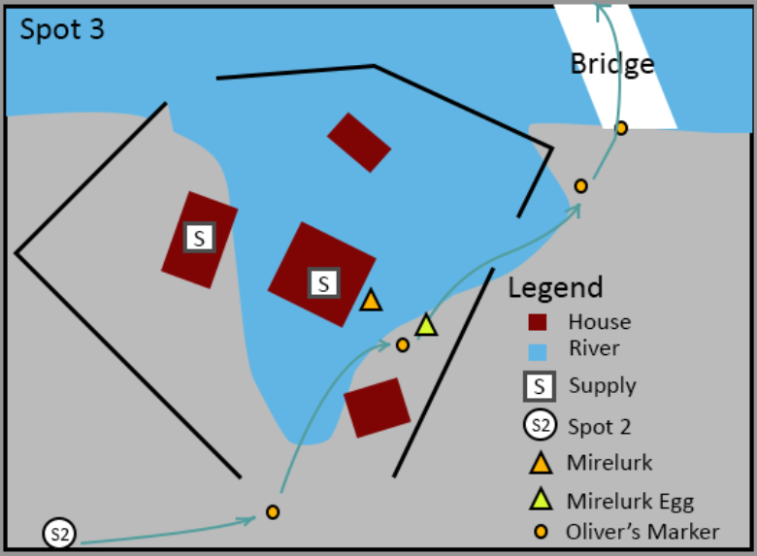

6-4

6-3

6-2

6-1
Figure 11: Top-down Map of Spot 3
Map Label | Event Description | Detail Information | NPC Interactions | Difficulty (1-10)
6-1 | Oliver leads the player to where he met the ghoul before. | - The entrance of Westwing Estate is where the third marker is. After arriving, Oliver will warn the player about the mirelurk in the water and go to the fourth marker.  - Oliver changes his moving speed and tries to avoid stepping on any mirelurk eggs. | - Lead the way  - Talking during leading  - Early warn the coming threat  - Moving speed shift | 2
6-2 | Oliver steps on a bunch of mirelurk eggs and wakes up a mature mirelurk. | - When the player follows Oliver to “6-2”, Oliver will break several eggs and wake up a mature mirelurk.  - Oliver runs away immediately and the player needs to fight with the enemies. | - Lead the way  - Talking during leading  - Moving speed shift  - Combat performance (run away) | 5
6-3 | Oliver gets injured and asks the player to help him | - Oliver is sitting near a stone and seems to be injured.  - The player needs to talk to him and he asks for a stimpak to stop bleeding.  - If the player doesn’t have any stimplak, Oliver will ask the playe to find some in the submerged estate. | - Idle animation  - Normal dialogue | 4
6-4 | Oliver gets up and talks about the next spot | - After the player gives Oliver 1 stimpak, he will get up and talk about the next spot. | - AI package shift  - Normal dialogue | 2

Spot 4 – Abandoned Houses
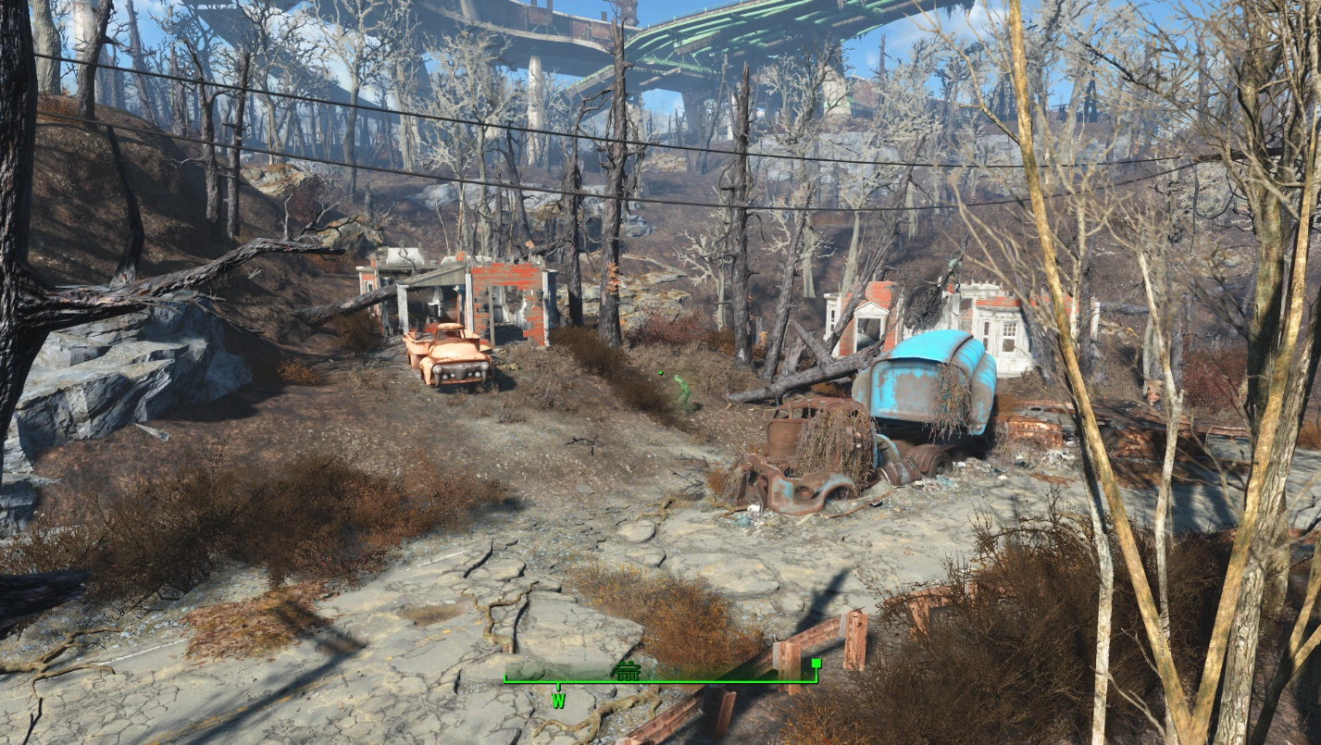

7-4

7-3

7-2

7-1
Figure 12: Screenshot of Spot 4
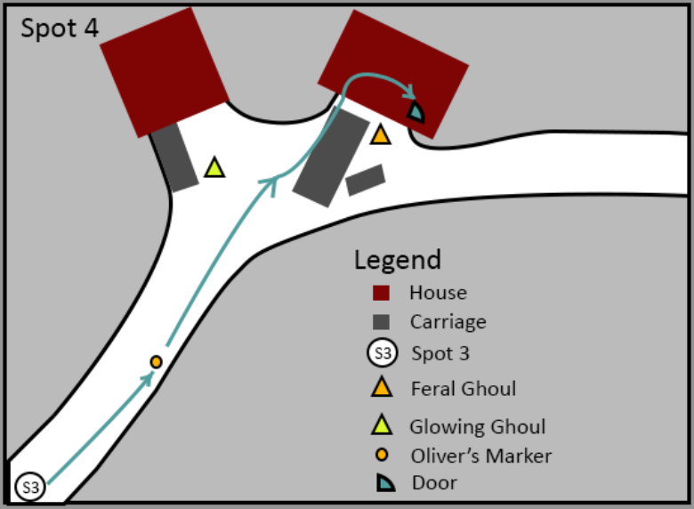

7-4

7-3

7-2

7-1
Figure 13: Top-down Map of Spot 4
Map Label | Event Description | Detail Information | NPC Interactions | Difficulty (1-10)
7-1 | Oliver leads the player to the final marker and warns the glowing ghoul. | - After getting across the river, Oliver stops in front of two abandoned house.  - He warns the player the glowing ghoul and gives the player 5 grenades.  - Oliver mentions he will follow the player after he kills the glowing monster. | - Lead the way  - Talking during leading  - Early warn the coming threat  - Idle shift  - Provide combat items  - Combat performance (hiding in a certain spot) | 3
7-2 | Fight with a glowing ghoul | - The player needs to kill the glowing ghoul wandering around the abandoned houses.  - Oliver will not follow or lead until the monster is dead. | - None | 6
7-3 | When the player gets close to the second house, a feral ghoul will wake up and attack the player. | - The feral ghoul is laying down near the other side of a truck.  - It will attack the player when the trigger is activated. | - Follow the player | 4
7-4 | The player finds a hatch door in the second house. | - Enter the hatch door in the second house. | - Follow the player | 2

Hidden Basement
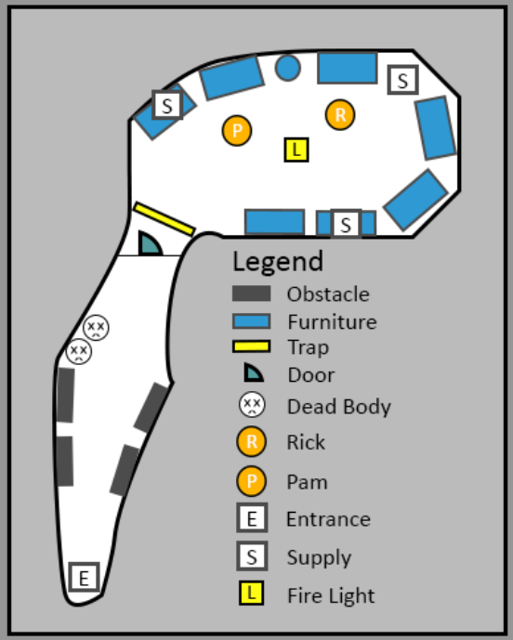

10

9

8
Figure 14: Hidden Basement
Map Label | Event Description | Detail Information | NPC Interactions | Difficulty (1-10)
8 | The storage area of the basement | - The player can see the furniture that is piled up in this area and find two human skeletons here.  - Someone has lined up the bodies neatly which shows some respect.  - The previous owner built this basement as a personal shelter while it turned out to be a failure.  - When the player enters this area, he can hear two people talking about food. | - Follow the player | 2
9 | Can Trap | - A can trap is set in the hallway. When the player triggers it, a scene will start. | - Oliver: Follow the player  - Pam: Idle shift  - Normal dialogue | 3
10 | Bedroom | - The player finally meets Pam and Rick.  - Oliver and the player mainly talk to Pam and learns what has happened to her.  - After a long conversation, the player needs to make the final decision which leads to 3 subsequent quests or one sad ending.  - The player can read both Pam and previous owner’s journals in the terminal. | - Dialogue  - Follow the player  - Animation Shift  - Cinematic Camera | 2

Sebsequent Quest – New Home: Diamond City (Ending 1)
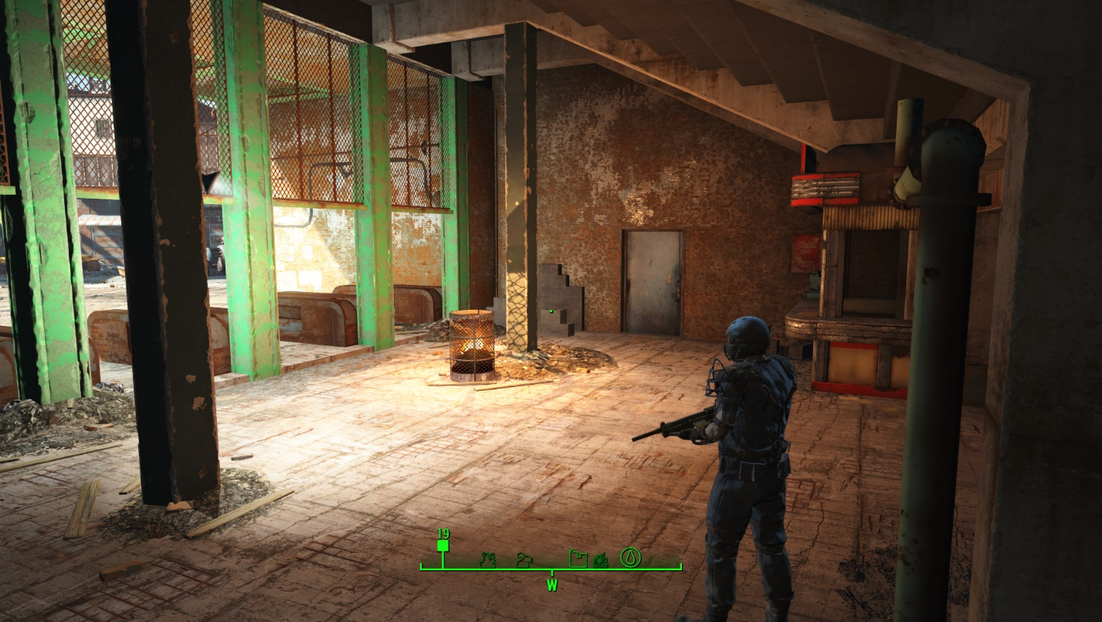

11
Figure 15: Diamond City Immigration Office - Exterior

12
Figure 16: Top-down Map of Diamond City Immigration Office
Map Label | Event Description | Detail Information | NPC Interactions | Difficulty (1-10)
11, 12 | The player needs to talk to Saul Checker to get immigration permission for Pam and Rick.  (New Home: Diamond City) | - The player can talk to Saul Checker after entering the office.  - The entrance of the office is set in the entrance of Diamond City.  - In the office, a long table separates the room into two parts and a door beside leads to the storage.  - The scene is triggered automatically when the player enters it.  - The player needs to get a file for Saul. | - Dialogue  - Follow the player | 2
Ending 1 | - Pam and Rick will live with Oliver in his editor’s office. Pam can help him with the editor’s work while Rick is mainly doing the housework.  - The second floor is the bedroom for Pam and Rick.

Sebsequent Quest – New Home: Goodneighbor (Ending 2)
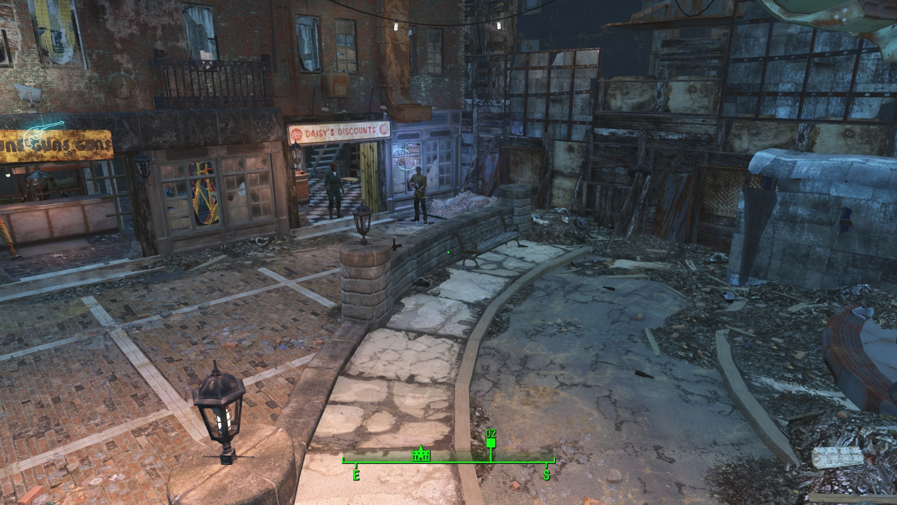

14

13
Figure 17: Screenshot of Daisy's Store
Map Label | Event Description | Detail Information | NPC Interactions | Difficulty (1-10)
13 | The player needs to talk to Daisy to ask her help Rick and Pam  (New Home: Goodneighbor) | - The player talks to Daisy in Goodneighbor.  - Daisy asks the player to find 2 stealth boys and give her. | - Dialogue  - Follow the player | 2
14 | Stealth boys | - The player can find two stealth boys in Goodneighbor. | None | 2
Ending 2 | - Pam and Rick will live with Daisy in her store.

Sebsequent Quest – New Home: Sanctuary (Ending 3)
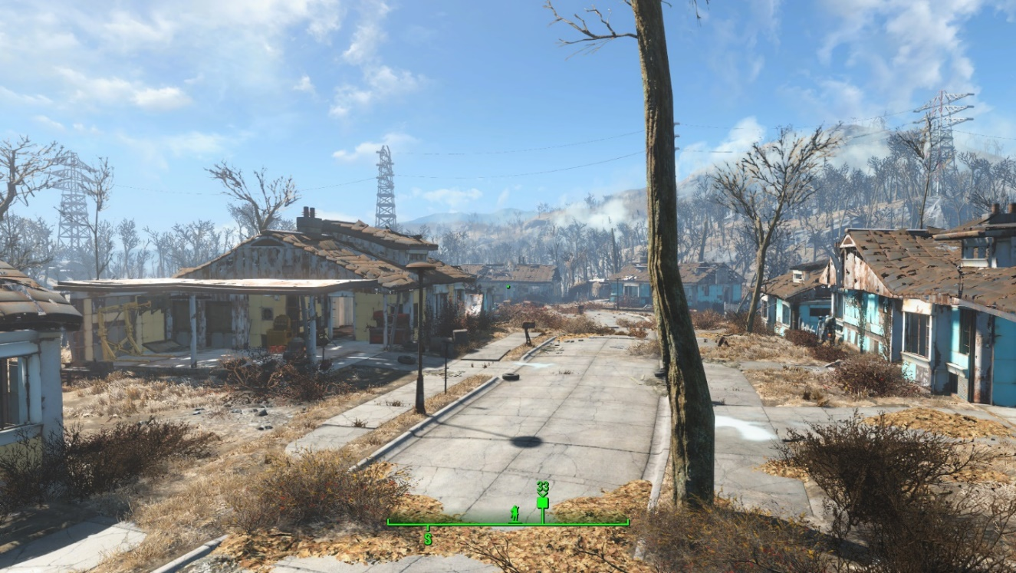

15
Figure 18: Screenshot of Sanctuary
Map Label | Event Description | Detail Information | NPC Interactions | Difficulty (1-10)
15 | The player needs to take Oliver to Sanctuary and ask him to draw a map  (New Home: Sanctuary) | - Pam says she doesn’t know where Sanctuary is and Oliver says he can help.  - The player takes Oliver to Sanctuary and gets a map from him  - Go back to give Pam the map. | - Dialogue  - Follow the player  - Idle animation | 3
Ending 3 | - Pam and Rick will live in Sanctuary with Minutemen.

Ending 4

16
If the player chooses to let Pam and Oliver stay in the basement, they will finally die near the river [16]. The player can find their bodies as well as a glowing ghoul’s body.

Objective(s)
- Create a vivid and favorable non-combat companion.
- Create two quest characters who can truly trigger the player’s empathy.
- Create meaningful choices opportunity.
- Believable environment set-up.

Hook(s)/Gameplay Highlights
- Vivid characters with abundant interactions.
- A Fallout-ish story with meaningful choices.

Campaign

Context
This series of quests start after the player completes the main quest “Getting a Clue” which means the player has been to Diamond City before. When the player enters Diamond City again, he hear about the establishment of another news agency. Then he meets Piper’s competitor, Oliver Trace, a novice journalist who asks the player to help him finish a special interview as his bodyguard.
The player needs to follow Oliver to find an abandoned cabin while Oliver can only remember the location roughly. Due to Oliver’s fear of blood, he can’t fight against the threats in the Commonwealth.

Backstory
Oliver Trace is planning to found his first newspaper, Unknown Commonwealth, which focuses on the unfamiliar issues/characters, such as ghouls, mirelurk lovers and super mutants. The feature character of the first issue is a female ghoul he met in the wilderness. Oliver asks the player to be his bodyguard since he can’t fight due to his blood phobia.
After a twisted journey, Oliver finally finds the ghoul Pam who is living in a nasty basement with a super mutant boy Rick. They are threatened by the endless glowing ghouls and short of food and aids. The player can choose to help them move to Diamond City, Goodneighbor, Sanctuary, or leave them alone.

Aftermath
Diamond City:
The player needs to convince, Saul Check, the immigration officer of Diamond City by stealing a file from the mayor’s office. After getting permission, Pam and Rick will move and work in Oliver’s news agency.
Goodneighbor:
The player needs to talk to Daisy, a ghoul shopkeeper in Goodneighbor to help Pam and Rick. Daisy will ask for 2 stealth boys as the pay of helping them. After fulfilling her request, she will pick up Pam and Rick by herself and let them live in her store.
Sanctuary:
The player can invite Pam to be the resident of Sanctuary. Since they have never heard Sanctuary before, the player needs to take Oliver there for drawing a map for them. After giving this map to Pam, they will head to where the Minutemen are.
Refuse to help:
If the player comes back after several weeks, he will find Rick and Pam’s bodies near the river beside the cabin. They dies when fighting with a glowing ghoul.

Development Schedule
Milestone | Date
LDD | 05/26/2020
Initial Gameplay | 06/08/2020
Gameplay Complete | 06/22/2020
Aesthetics | 07/06/2020
RTM | 07/21/2020

Key Theme References

Oliver Trace’s Office
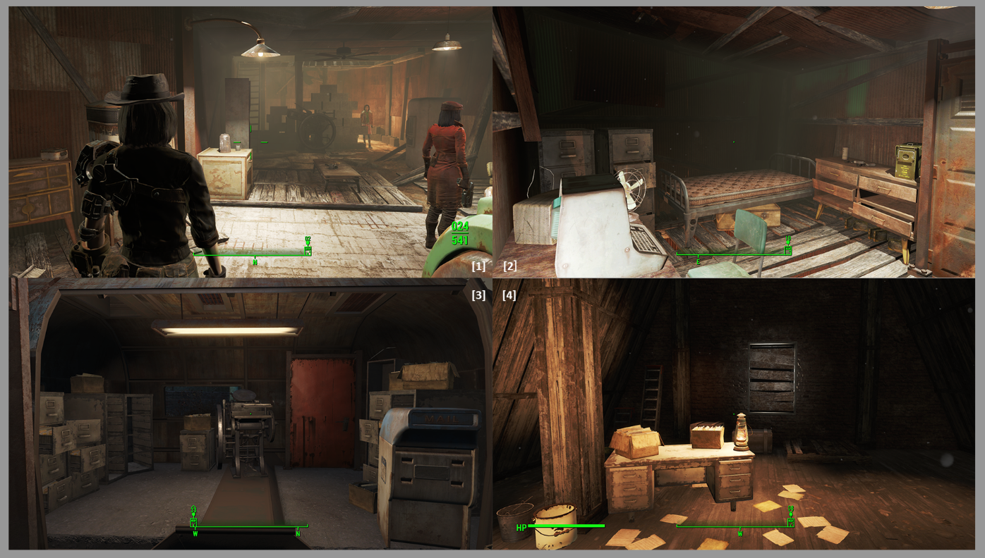
Figure 19: Contact Sheet for Oliver’s Office [1][2][3][4]

Abandoned Cabin
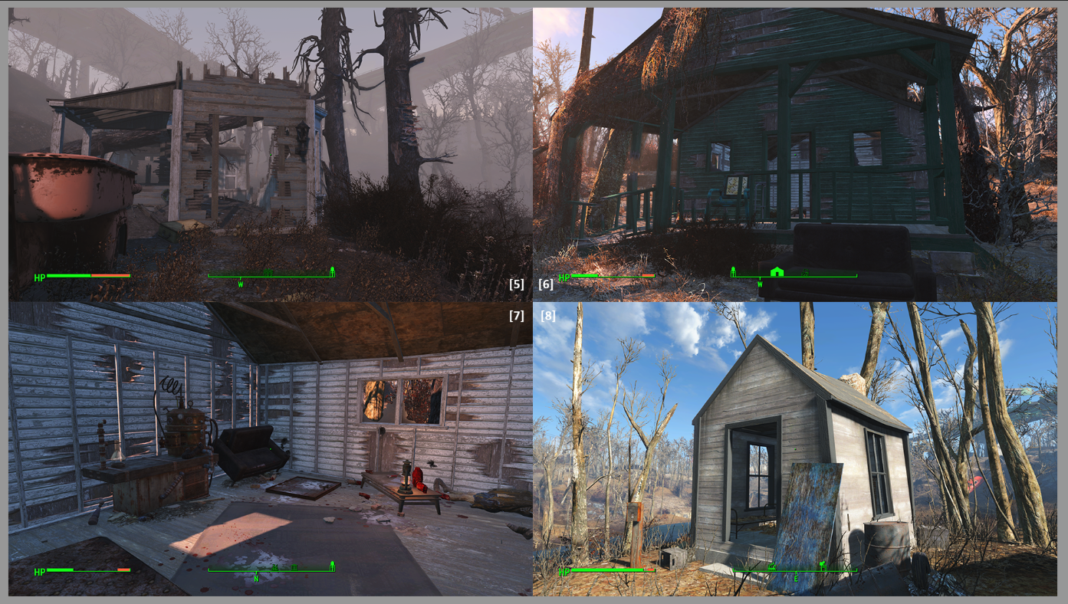
Figure 20: Contact Sheet for Abandoned Cabin [5][6][7][8]

Hidden Basement
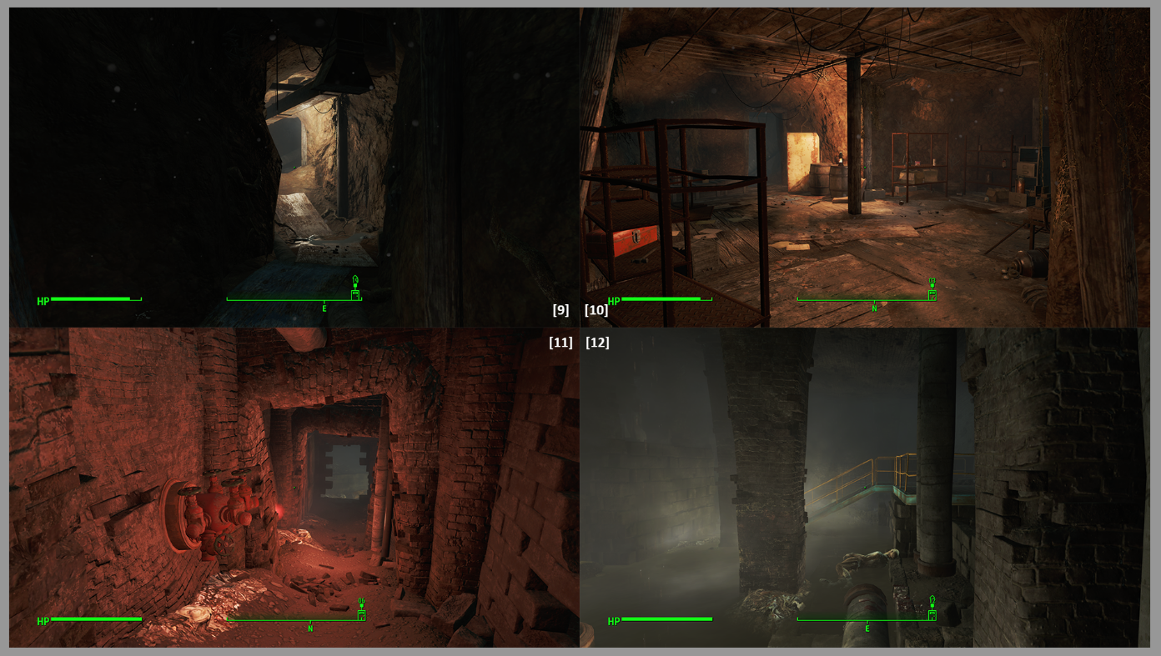
Figure 21: Contact Sheet for Hidden Basement [9][10][11][12]

Immigration Office
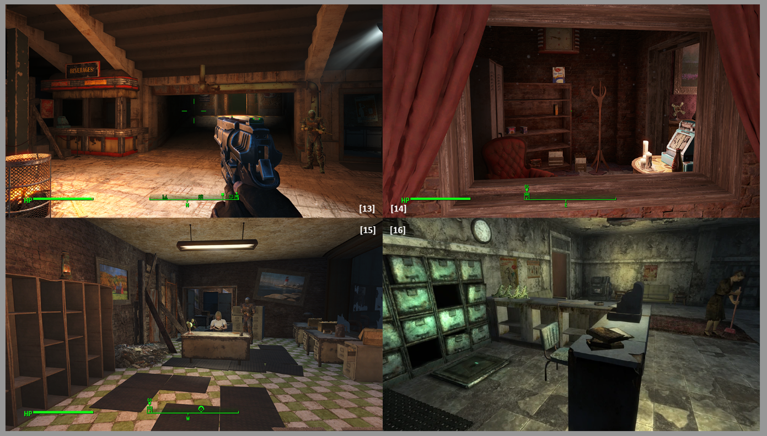
Figure 22: Contact Sheet for Immigration Office [13][14][15][16]

Requirements
Map Label | Description | Type | Priority
2,3,4,5 | Modify NPCs’ combat AI which makes them refuse to fight and perform a certain idle pose. | Scripting | High
2,3,4,5 | Escort AI package and preferred route | Scripting | High
2,3,4,5 | An obvious marker | Decal | Middle
All | Dialogue Voice | Voice Recording | Middle

Appendix A: Quest Summary

Main Quest
- The Exclusive Report
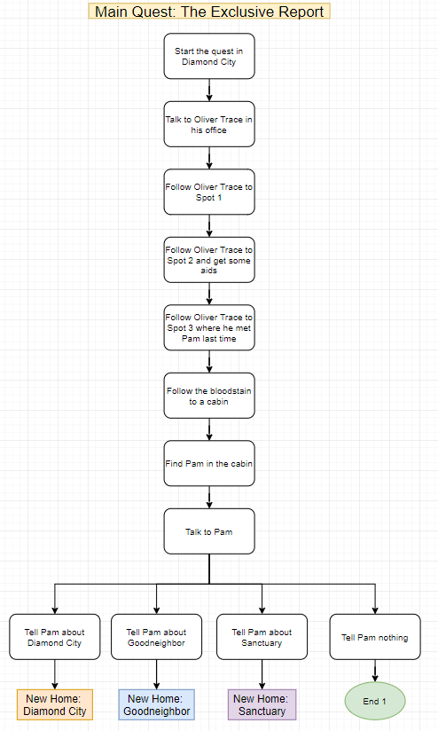
- New Home: Diamond City
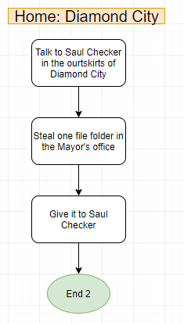
- New Home: Goodneighbor
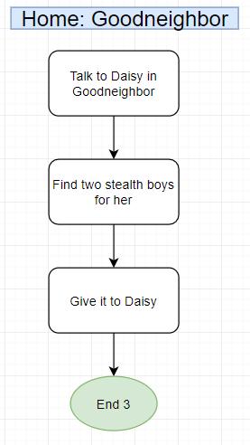
- New Home: Sanctuary
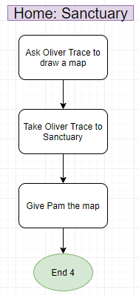

Appendix B: Main Characters

Oliver Trace
Male Human, 24
Oliver Trace admires Piper Wright while dislikes Publick Occurrences. He admires Piper’s bravery and insistency while regards some reports about the synths and the Institute as “incredibly nonsense”. He can feel the anxiety and nervousness hidden in Diamond City. That’s why he desires to found a newspaper reporting the vivid unknown lives in the Commonwealth, no more conspiracy. He hopes his report will bring some fun, warmth and hope to Diamond City.
His first protagonist is an intelligent female ghoul whom he has occasionally met before. Oliver is a good shooter when facing a dummy but due to his blood phobia, he’s helpless in any real fight. That’s why he asks the player to be his bodyguard to complete the interview in the wilderness.

Pam Johns
Female Ghoul, ??
After losing her son in that unfortunate accident, Pam was always alone. She had been living in Diamond City for several months before they expelled all the ghouls. But that means nothing. Diamond City, the woods, the moor are the same to her, just a temporary shelter. She knows how to survive in the Commonwealth and even if she fails, death is also acceptable.
But when she met Rick, everything has changed. She can see the helpless, innocent spirit trapped in that muscular, frightening body. She taught him how to hunt mirelurks, how to control his strength, how to express himself. The boy makes her feel alive again, and she would like to die for him.

Rick
Male Super Mutant, around 9
Rick had a normal childhood until he got infected by FEV virus. He remembers several discrete memory segments such as his birthday party, hospital and then the wilderness. He tried to come closer to Diamond City, but all he got was the bullets and shouts. He kept wandering in the wilderness for a while before meeting Pam.
He would like to kill all the annoying ghouls around their cabin while Pam doesn’t want him to do anything like this. Pam always says, “It’s grown-ups’ business.”

Saul Checker
Male Human, 42
An immigration officer in Diamond City. Just like common people, he can’t resist the temptation of money which easily leads him to some troubles. Two newcomers have been identified as escaped criminals and unfortunately, Saul has provided some help. He needs help to get rid of the problem.

Appendix C: Dialogue Flow

Oliver Trace
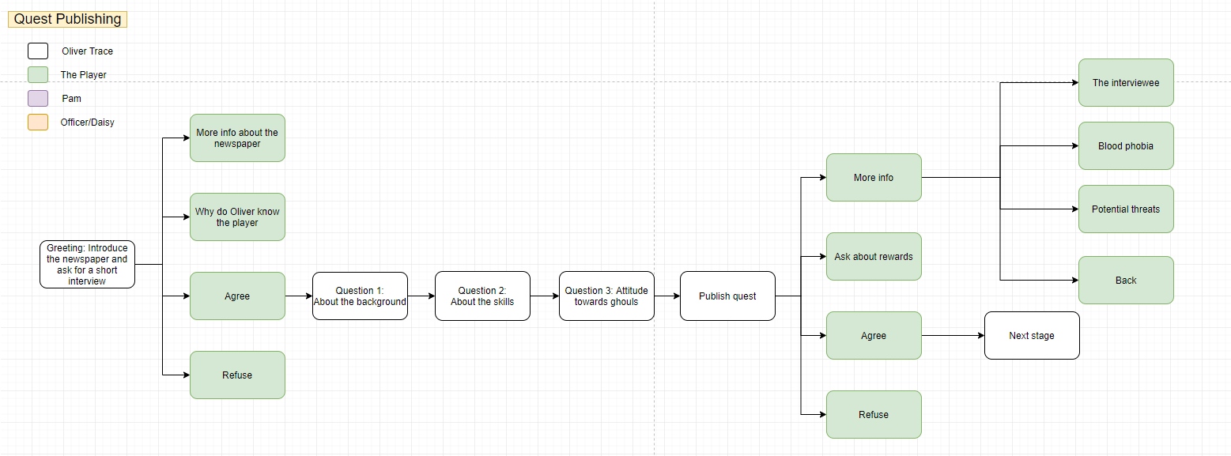
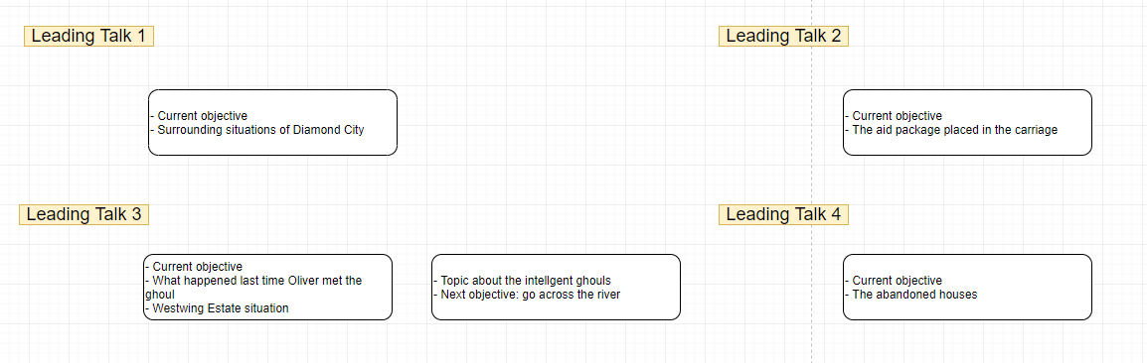
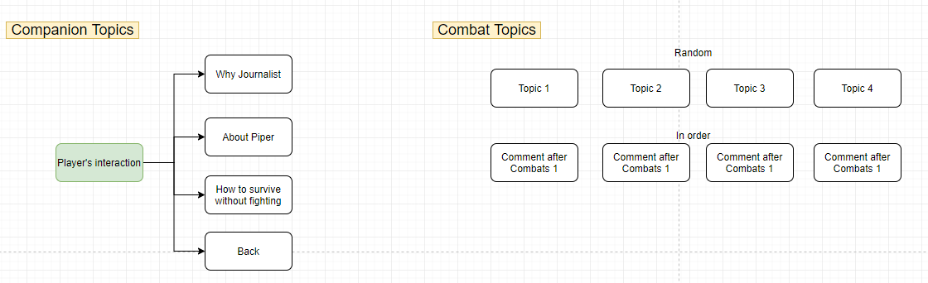
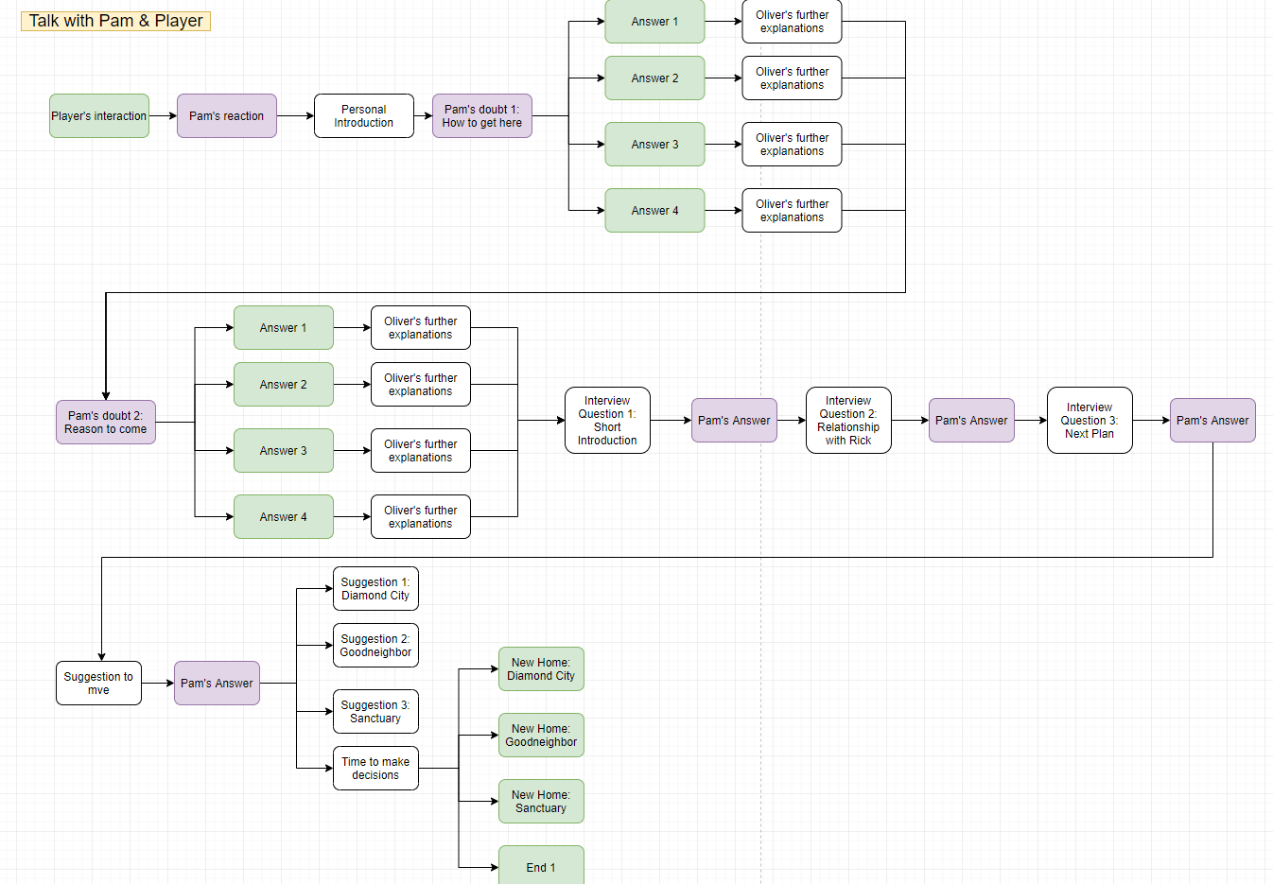
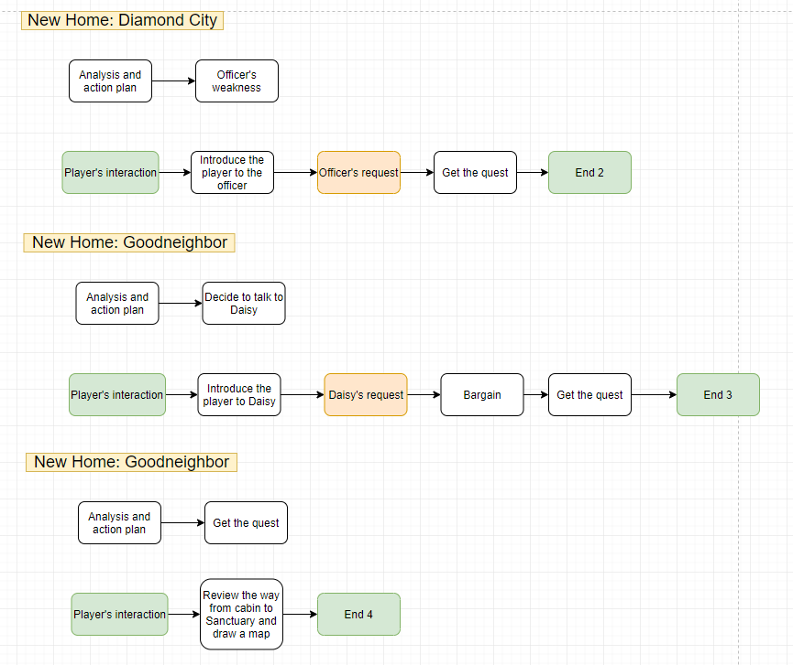

Appendix D: Dialogue Document
//depot/C29/Students/yzhang4/Fallout4/RTM/Dialogue Document.docx

References
[Cover Image] https://en.wikipedia.org/wiki/History_of_American_newspapers#/media/File:Representative_journals_of_the_United_States_1885.jpg
[1][2][3][4][5][6][7][8][9][10][11][12] Screenshots from Fallout 4

