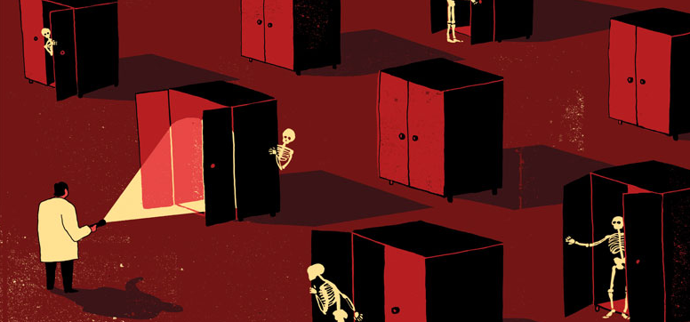

Fallout 4: The Skeleton in the Closet
  - Version 2.0
Designer: | Yan Zhang
Document Date: | 03/01/2020
Intended Level Delivery Date: | 05/04/2020

Document Revisions Table
Version | Description | Requestor | Date
1.0 | Initial Document | Prof. O | 03/01/2020
2.0 | - Update the quest flow chart  - Update all the maps  a) Complete player’s route  b) Scale  c) More details  d) The maps are drawn on grids, but they are hidden in the screenshots to prevent them from looking too busy.  - Update all the descriptions of the maps  - Update context, backstory and aftermath  - Update the character description and add a new character, the postman.  - Fix grammatical mistakes and other format issues | Prof. O | 04/22/2020

Table of Contents
Table of Contents 2
Table of Figures 3
Level Information 4
Quick Summary 4
Quest Flow Chart 5
Level Map(s) 6
Overview Map 6
Section 1 Red Rocket Stop 8
Section 2 Alford Town - 1 9
Section 3 Hawker’s Gallery – 1st Floor - 1 11
Section 4 Alford Town - 2 14
Section 5 Hawker’s Gallery – 1st Floor – 2 16
Section 6 Hawker’s Gallery – 2nd Floor 17
Section 7 Hawker’s Gallery – 3rd Floor 19
Section 8 Ending 1: Fight for Laure 20
Section 8 Ending 2: Abandon Laure 21
Hook(s)/Gameplay Highlights 22
Skill Progression Chart 22
New Skills/Gameplay Mechanics 22
Context 23
Backstory 23
Aftermath 23
Development Schedule 23
Aesthetic References 23
Alford 24
Hawker’s Gallery 25
Characters/Dialog Flow 26
Character 1: Moss 26
Character 2: Nigel Hawker 29
Character 3: Laure 29
Character 4: Kenny Hawker 30
Character 5: Postman 30
Risks 30
Key Asset Needs 30
References 32

Table of Figures

Figure 1: Overview Map – Red Rocket Stop [1] 6
Figure 2: Overview Map - Alford Town & 1st Intrusion to the gallery 6
Figure 3: Overview Map – 2nd Intrusion to the gallery 7
Figure 4: Red Rocket Stop 8
Figure 5: Alford Town 9
Figure 6: Hawker's Gallery - 1st Floor with Scale & Patrolling Route 11
Figure 7: Hawker's Gallery - Lobby & Cafe Area 12
Figure 8: Alford Town - 2 14
Figure 9: Hawker's Gallery - 1st Floor - 2 16
Figure 10: Hawker's Gallery - 2nd Floor 17
Figure 11: Hawker's Gallery - 3rd Floor 19
Figure 12: Ending 1 - Attic & Alford 3 20
Figure 13: Ending 2 – Attic 21
Figure 14: Contact Sheet 1 [2,3,4,5] 24
Figure 15: Contact Sheet 2 [6,7,8,9] 25
Figure 16: Dialog: Moss, Stage 20 27
Figure 17: Dialog: Moss, Stage 50 28
Figure 18: : Dialog: Moss, Stage 80 28
Figure 19: Dialog: Hawker, Stage 60 29

Level Design Document

Level Information

Quick Summary
“The Skeleton in the Closet” is a standalone quest for Fallout 4. The quest is set after the player completes the main quest “Getting a clue” and starts at Red Rocket Stop near Sanctuary.
The quest combines story-telling, combats and interesting NPC interactions. It contains a classic Fallout style story supported by both NPC interactions and environmental story-telling, while also provides combat stages that are suitable for both straight-forward and stealth player. The player will meet meaning choices in the quest which will truly influence the NPC’s life.
A side quest is available in Alford, which provides a powerful weapon to the player. The side quest is mainly designed for the player who is fond of exploration. The player can get some benefits in the main quest if he completes the side quest.

Quest Flow Chart
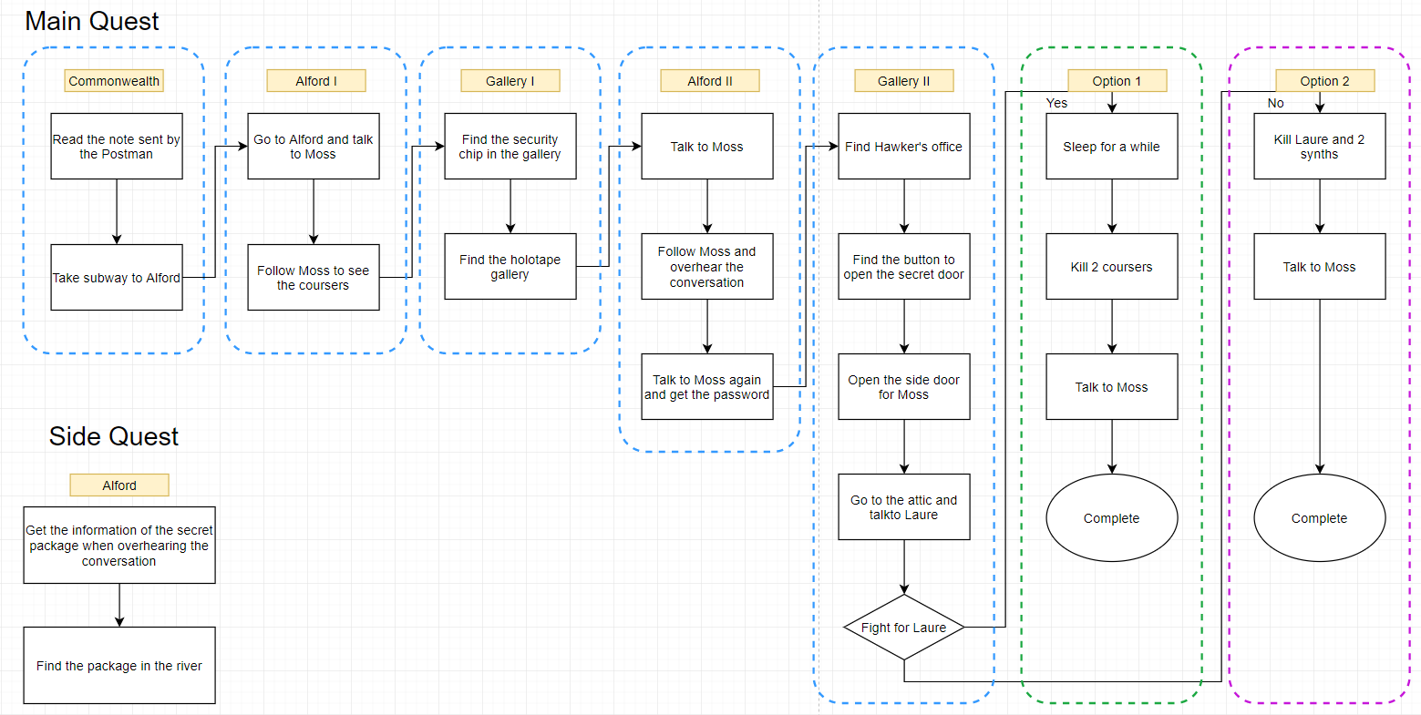

Level Map(s)

Overview Map
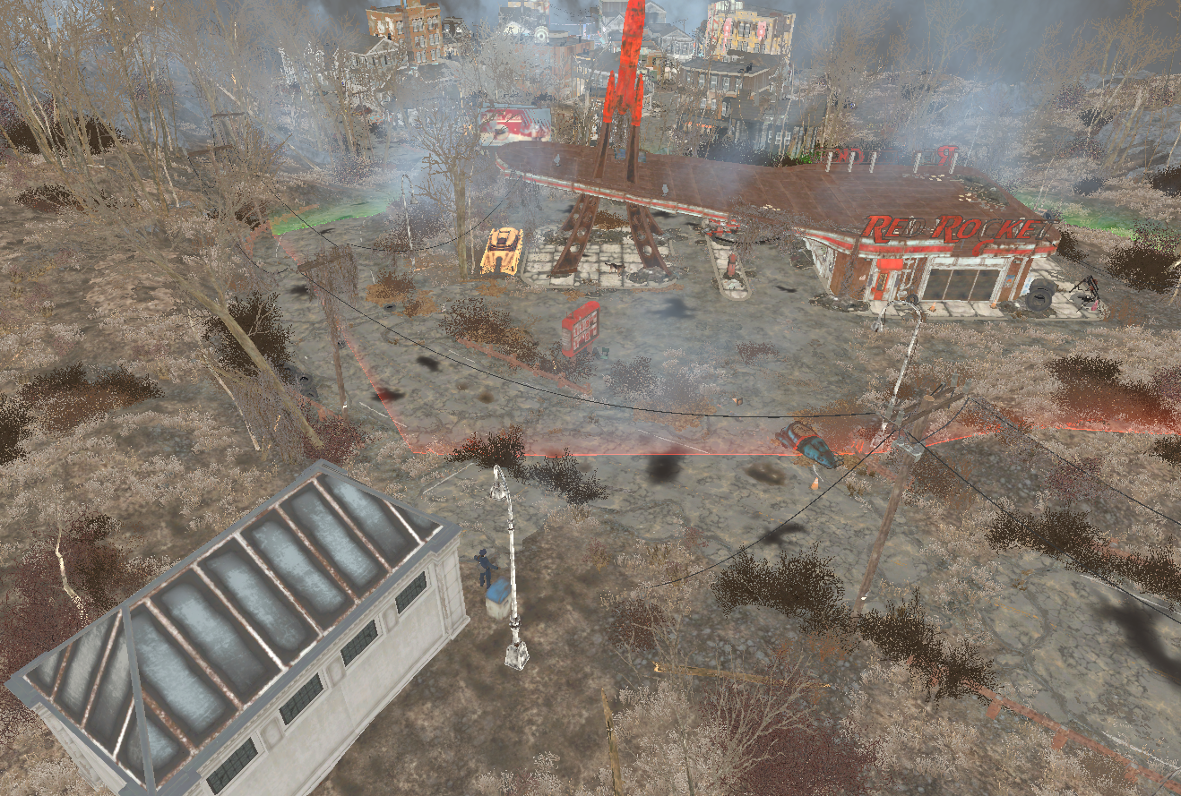

1
Figure 1: Overview Map – Red Rocket Stop [1]
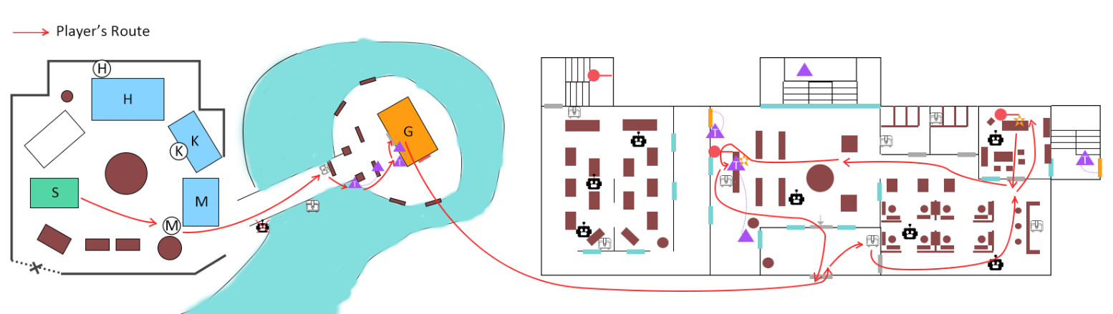

2

32
Figure 2: Overview Map - Alford Town & 1st Intrusion to the gallery
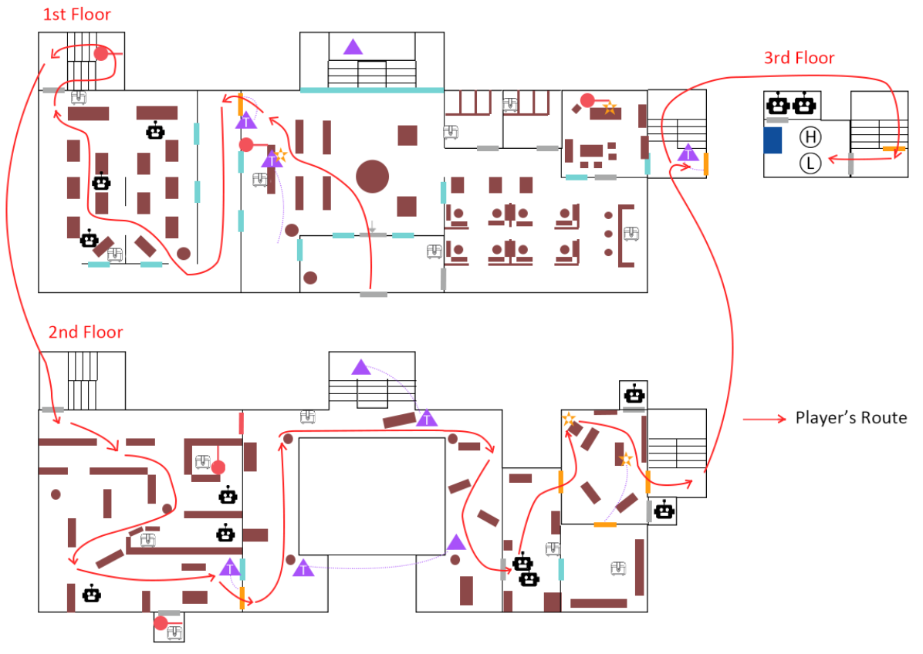

4
Figure 3: Overview Map – 2nd Intrusion to the gallery
Map Label | Top Level Summary/Objective
1 | The starting point of the quest. The player can get the note from the postman and take the subway to the Alford.
2 | - The player needs to find Valentine’s friend Moss in Alford. After listening to the current situation, the player needs to enter Hawker’s Gallery to find the security chip and the holotape.  - After the first intrusion, the player needs to tail after Kenny to overhear his conversation with Nigel Hawker. Then Moss will ask the player to enter the gallery again to find the mysterious woman in the attic.  - In one end, the player needs to fight against two coursers outside the gallery.  - The side quest asks the player to find a secret package under the bridge.
3 | Hawker’s Gallery – 1st Intrusion  - Only the lobby and the café area are accessible to the player.  - The player needs to fight with some synths and turrets.  - The player has a chance to observe the situation of the second floor and the exhibition hall.
4 | Hawker’s Gallery- 2nd Intrusion  - The player can open the gate to the exhibition hall and go to the second floor via the side stairs.  - The player needs to find the entrance to the attic in Hawker’s gallery.  - The player will meet Laure in the attic and make his final decision.

Section 1 Red Rocket Stop
[2]
[1]
Figure 4: Red Rocket Stop
Map Label | Objective/Simple Action Summary | Challenge/Conveyance Details | Approx. Difficulty (1-10)
1 | The player needs to find a postman beside the subway station near Red Rocket and get a note from Valentine.  After reading the note, the player knows he needs to go to Alford, a town outside Commonwealth. | - The subway station is built on the way from Sanctuary to Red Rocket. The player can easily find it.  - A map marker is enabled to show the location of the subway station.  - A mailbox is placed near the subway station. | 1
2 | Take the subway to Alford. | - The subway station is near the postman.  - A “subway” sign is put above the door. | 1

Section 2 Alford Town - 1
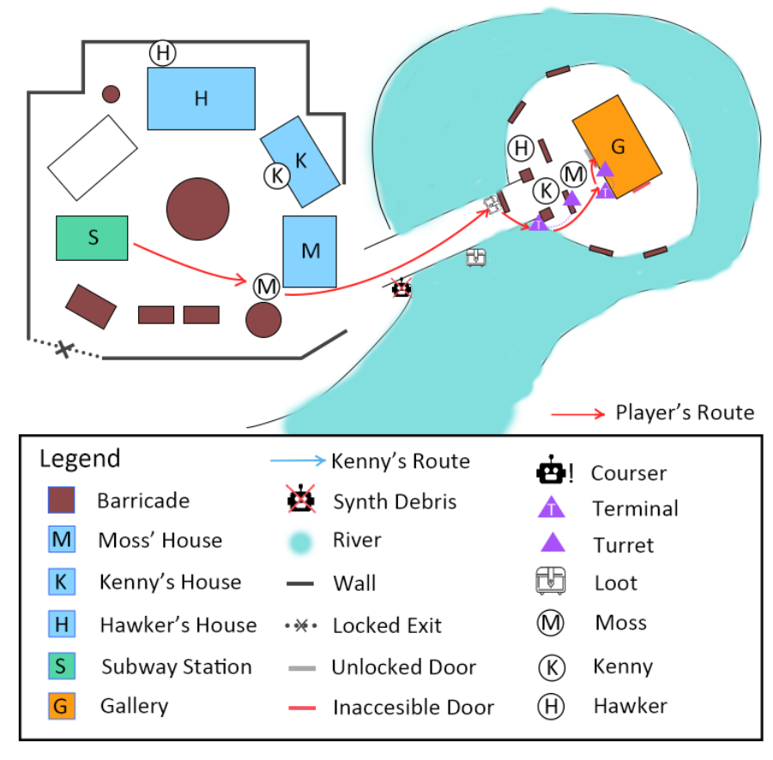
[7]
[6]
[5]
[4]
[3]
Figure 5: Alford Town
Map Label | Objective/Simple Action Summary | Challenge/Conveyance Details | Approx. Difficulty (1-10)
3 | Arrive in Alford | - The gallery is in the player’s sightline when he arrives. The big tree next to the gallery helps to make it a landmark.  - Moss’s house is also in front of the subway where Moss is reading a newspaper. | 1
4 | Talk to Moss and choose the right answer to get his trust | - According to the note, the player needs to mention an agreed code “Honey Bear”.  - Get information about the case:  - The gunshots.  - Nigel Hawker’s weird action.  - Gallery’s position.  - More details | 2
5 | Follow Moss to see the synth body pile | Moss leads the player to the river:  - Next objective: find the security chip & holotape in the gallery  - Gallery is out of his control  - The synth bodies near the river.  - Moss’ relationship with the Institute. | 2
6 | Two turrets are guarding the bridge. The player can use the corresponding terminal to make them as his allies. | - One turret is at the end of the bridge and the other is on the second floor of the gallery platform.  - Each turret has a spline leading to the corresponding terminal.  - The positions of the covers make sure the player’s safety while operating the terminals.  - A weapon box is placed near the first cover and the player can get a sniper from it. | 4
7 | Inaccessible Side Door | If the player looks around the gallery, he can find a side door on the right side. But the door is not accessible now. | 2

Section 3 Hawker’s Gallery – 1st Floor - 1
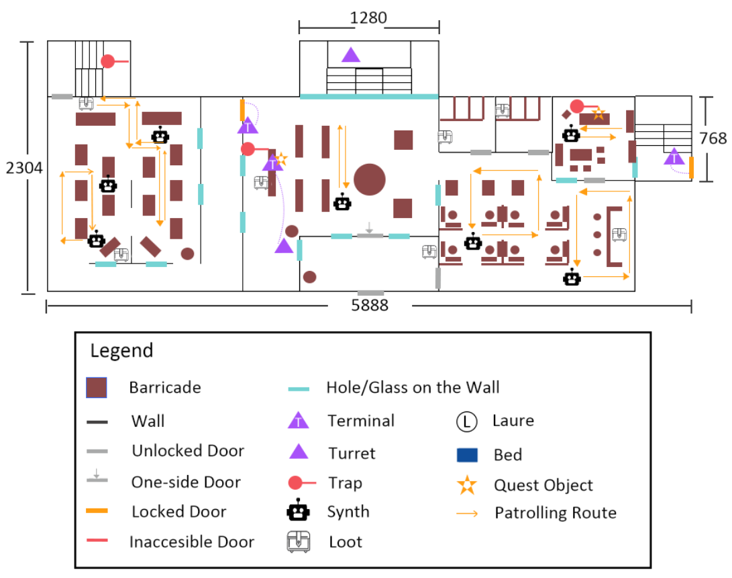
Figure 6: Hawker's Gallery - 1st Floor with Scale & Patrolling Route
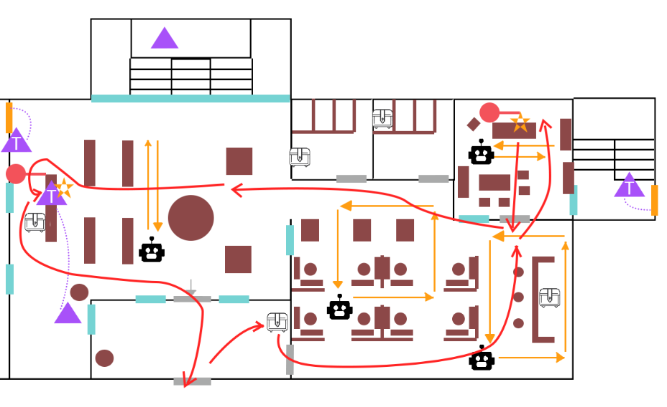
[14]
[13]
[12]
[11]
[10]
[9]
[8]
Figure 7: Hawker's Gallery - Lobby & Cafe Area
Map Label | Objective/Simple Action Summary | Challenge/Conveyance Details | Approx. Difficulty (1-10)
8 | - The player can observe the inner situation from the reception room.  - A weapon case is placed near the door to the café area. The player can get a combat rifle and some armors.  - The door to the café area is unlocked while the door to the lobby is chained. | - The glass door makes the player be able to see the chains.  - The player can locate a turret in the lobby through the window.  - The statue in the lobby is set as a significant piece that helps the player remember the room. | 3
9 | - Two synths are patrolling in the café area. The player can choose to sneak around to avoid fighting with them or shoot directly.  - A shotgun is put behind the counter. | The hole on the wall provides the player with visibility to Moss’ office. | 5
10 | - Get the security chip in Moss’ office.  - Fight with the synth inside the office.  - A laser trap behind the table may hurt the player. | - The synth won’t see the player until he enters the office while the player can see or hear it before.  - The player can see the side door which is inaccessible now from the hole in the office. | 3
11 | - The synth in the lobby is spawned after the player enters the area.  - The turret in the lobby won’t see the player until the player gets close to the terminal.  - The player can choose to destroy the turret directly or deactivate it via the terminal. | - The synth’s patrolling route exposes itself to the player directly and the statue can be used as a full cover.  - The spline indicates the connection between the terminal and the turret.  - The player can see a turret that doesn’t attack him on the main stairs.  - The player can observe the placement of the catwalk on the second floor. | 5
12 | - The holotape is in the terminal on the counter.  - A trap is put behind the counter.  - A sledgehammer is put behind the counter. | - The objective marker helps the player to locate the right terminal and the text on the screen tells the player how to reject the holotape. | 4
13 | - The gate to the exhibition door needs the terminal beside to unlock while the player doesn’t have the password now. | - The player can see through the windows to observe the exhibition hall. | 2
14 | The player can open the chained door from the lobby side. | - Chains | 2

Section 4 Alford Town - 2
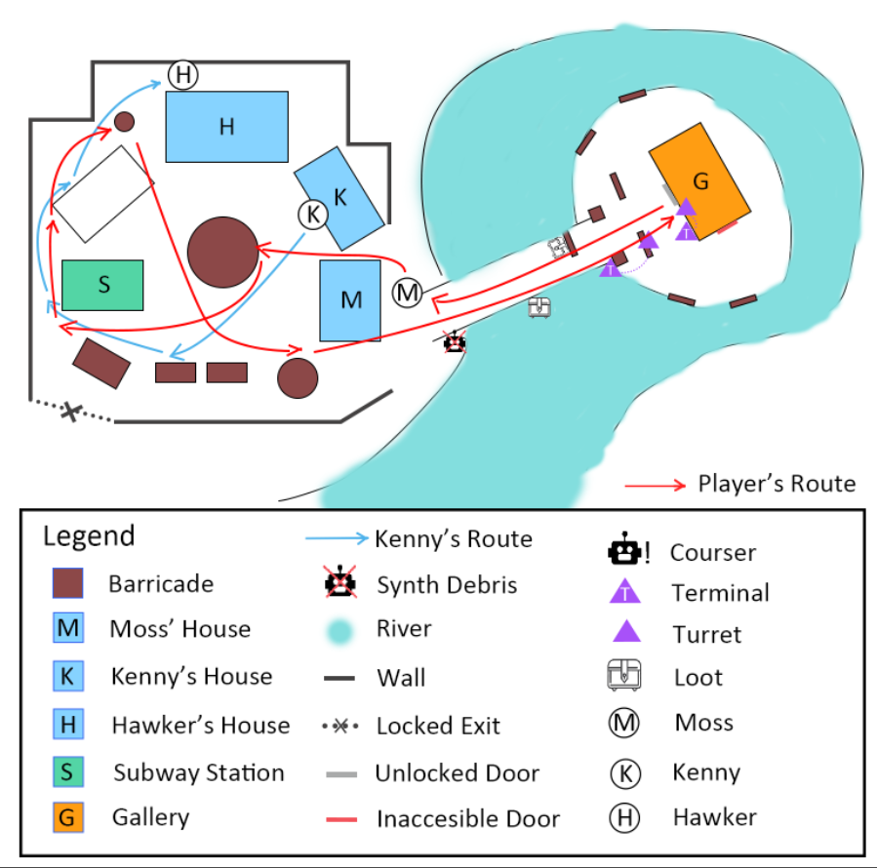
[19]
[18]
[17]
[16]
[15]
Figure 8: Alford Town - 2
Map Label | Objective/Simple Action Summary | Challenge/Conveyance Details | Approx. Difficulty (1-10)
15 | - Talk to Moss and give him the chip & holotape.  - Moss asks the player to tail after Kenny to see what he is doing. | - The player can see Kenny walking out of his house when Moss is talking about him. | 1
16 | - Kenny will stop three times before he reaches the final destination.  - The player needs to hide from Kenny’s sightline as well as keep distance from him. | - When the player gets too close to Kenny, he will stop to look at the player and warn him to get away from him.  - Kenny will stop to check if someone is following him during the whole process.  - Kenny will change his moving speed, so the player needs to pay attention to his movement. | 5
17 | - A cinematic moment between Kenny and Nigel Hawker. They reveal the reason for the night attacks in the conversation.  - The side quest starts when they mentioned the secret package. | - The player’s movement is restricted when the conversation is going.  - The camera is set between Kenny and Nigel Hawker. | 3
18 | Tell Moss about what the player has overheard. Moss will ask the player to enter the gallery again, to find the woman in the attic. | The next objective is divided into several sub-objectives.  - Open the gate to the exhibition hall  - Get to the second floor  - Find Hawker’s office  - Find the entrance to the attic. | 3
19 | Side Quest:  The player can find the secret package in the river under the bridge. | Some glowing mushrooms and seaweed are placed near the package. | 4

Section 5 Hawker’s Gallery – 1st Floor – 2
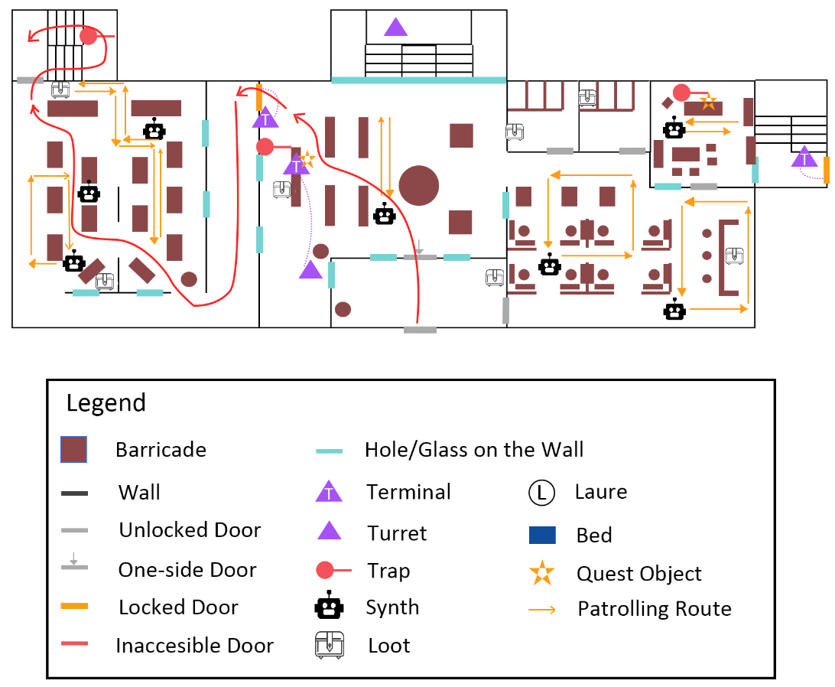
[23]
[22]
[21]
[20]
Figure 9: Hawker's Gallery - 1st Floor - 2
Map Label | Objective/Simple Action Summary | Challenge/Conveyance Details | Approx. Difficulty (1-10)
20 | Use the password to open the gate to the exhibition hall | - The objective will be updated after the door is opened. | 2
21 | Three synths (2 middle-ranged, 1 melee) are patrolling in the exhibition hall.  The player needs to fight with them and get to the exit to the side stairs. | - The holes on the walls help the player locate the positions and patrolling routes of the synths.  - Ammo and health supplies are available in the room. | 6
22 | Open the door to the side stairs | - A sign which says “exit” is placed above the door.  - Two other signs in the room show the direction of the door. | 2
23 | Laser trap on the side stairs. | - Laser beam | 4

Section 6 Hawker’s Gallery – 2nd Floor
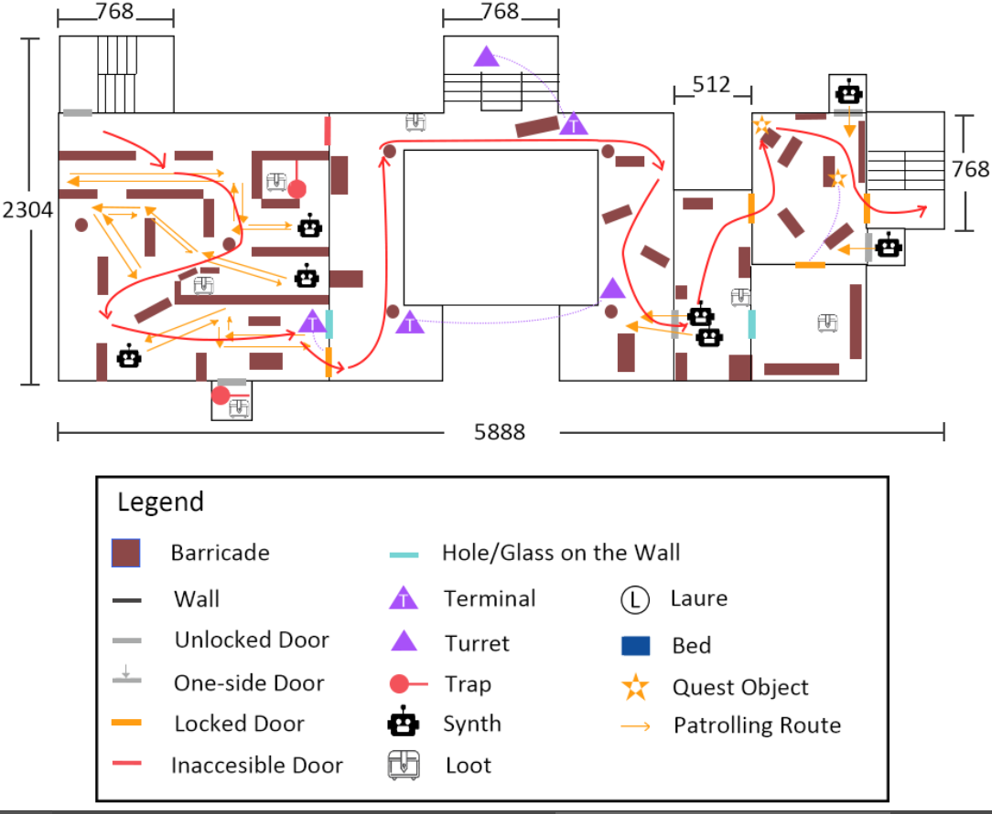
[33]
[29]
[28]
[32]
[31]
[30]
[27]
[27]
[26]
[25]
[24]
Figure 10: Hawker's Gallery - 2nd Floor
Map Label | Objective/Simple Action Summary | Challenge/Conveyance Details | Approx. Difficulty (1-10)
24 | When the player gets to the second floor, the objective will be updated. | / | 1
25 | 3 Patrolling synths (2 middle-ranged and 1 melee) | - The players can observe their patrolling routes and sneak around or fight with them directly.  - The player can see the catwalk on the second floor from a blocked door and the hole on the wall.  - Three supply cases are available in the storage area. One case needs the player to disarm a trap first. | 6
26 | The player needs to unlock the door via the terminal beside. | The unlocked door here requires the player to destroy all the patrolling synth in the room. Otherwise, he can’t get a safe environment to operate it. | 3
27 | Two turrets & terminals on the catwalk.  - The player can choose to use the terminals to deactivate the turrets or destroy them directly. | - The catwalk area is quite open where the player can see the lobby on the first floor. It’s easy for the player to memorize this area.  - The player can follow the splines to recognize the connection between the terminals and turrets.  - The player faces the door to the next area directly when he gets out of the storage. | 5
28 | Ambushing Synths  When the player gets to the right side of the catwalk, two synths will come out from the exit door. | The ambushing moment may surprise the player.  Covers are provided on the catwalk | 5
29 | Hallway in the office area.  A safe point.  The player needs to lockpick the door of Hawker’s office. | - The player can locate the position of the safe by looking through the door on the wall.  - Health supply is available in this area. | 2
30 | After entering the office, two synths appear to attack the player immediately. | - The two synths appear from different directions.  - The synths are spawned after the player enters the room which requires the player to react quickly. | 6
31 | Locate the secret door and find the button to open it. | - The gap between the secret door and walls  - The trail on the ground beside the secret door.  - The position of the button enables the player to see the interactive feedback. | 5
32 | Open the side door for Moss | - The terminal is placed beside the side door.  - Moss will lead the player to the attic directly. | 3
33 | (Optional) Hawker’s Personal Storage | If the player finds the key on Hawker’s desk, he can open the door to the storage. | 3

Section 7 Hawker’s Gallery – 3rd Floor
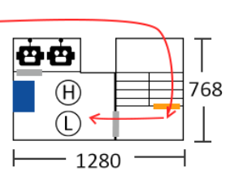
[35]
[34]
Figure 11: Hawker's Gallery - 3rd Floor
Map Label | Objective/Simple Action Summary | Challenge/Conveyance Details | Approx. Difficulty (1-10)
34 | The door to the attic | - The door to the attic is inaccessible to the player unless Moss helps him. | 3
35 | Final dialogue and decision | - After talking to Laure and Nigel, the player needs to make his final decision. | 3

Section 8 Ending 1: Fight for Laure
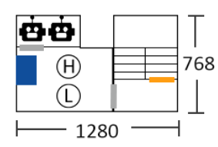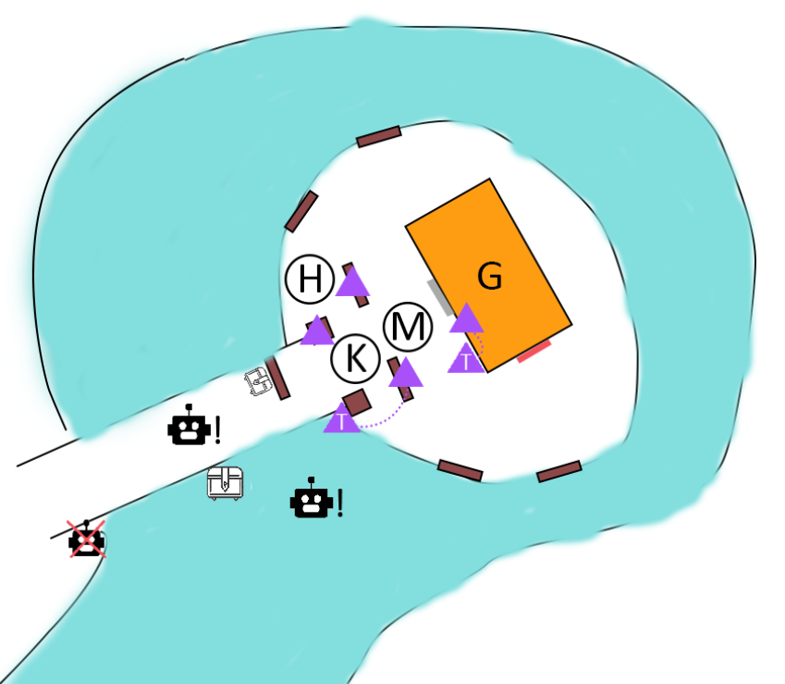
[38]
[37]
[36]
Figure 12: Ending 1 - Attic & Alford 3
Map Label | Objective/Simple Action Summary | Challenge/Conveyance Details | Approx. Difficulty (1-10)
36 | The player needs to take a nap for an hour and prepare for the final combat. | / | 1
37 | Combat Support  - The previous turrets outside the gallery  - Two more turrets  - Moss, Nigel and Kenny | / | 2
38 | Two coursers will appear after the player talks to Moss.  The player needs to kill them and then talk to Moss to complete the quest | - One courser is spawned on the bridge, taking advantage of the covers.  - The other courser is spawned in the river, trying to attack from a different direction.  - The difficulty of the combat varies due to the number of turrets available. | 7

Section 8 Ending 2: Abandon Laure
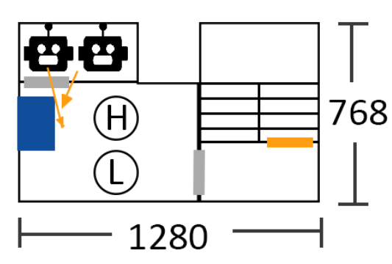
[39]
Figure 13: Ending 2 – Attic
Map Label | Objective/Simple Action Summary | Challenge/Conveyance Details | Approx. Difficulty (1-10)
39 | - Two synths hiding in the restroom will come out and attack the player.  - Laure turns hostile to the player  - The player needs to kill all of them and talk to Moss to complete the quest. | - The synths appear suddenly and have no chance for the player to prepare. | 5

Hook(s)/Gameplay Highlights
- A Fallout 4-ish story with meaning choices
- Interesting NPC interactions such as tailing after
- Support multiple player styles

Skill Progression Chart
Skill | Red Rocket | Alford 1 | Gallery 1st Floor | Alford 2 | Gallery 2nd Floor | Gallery 3rd Floor
Look for Items | Intermediate | Reinforced | Reinforced |  | Reinforced
Dialogue |  | Intermediate |  | Reinforced |  | Reinforced
Follow an NPC |  | Introduced |  | Reinforced
Observe surroundings |  | Introduced | Reinforced |  | Reinforced
Lockpick |  | Intermediate | Reinforced |  | Reinforced
Deactivate Traps |  |  | Introduced |  | Reinforced | Reinforced
Stealth |  |  | Introduced | Reinforced | Reinforced
Combat |  |  | Intermediate |  | Reinforced
Hack Terminals |  |  | Intermediate |  | Reinforced
Tail after an NPC |  |  |  | Introduced

New Skills/Gameplay Mechanics
- Tailing after an NPC
  - In a specific stage, use a script to detect the distance between the player and the target.
  - If the player gets too close to the target, he/she will stop and look at the player. Sometimes he/she will ask the player to go away.

Context
The standalone quest happens after the player completes the main quest “Getting a Clue”. Before the quest happens, the player has already been a friend of the detective, Valentine. Then, one day, the busy detective asks the player to help him investigate a case.
Alford is built by those who want to obtain a peaceful life. So the town is outside the Commonwealth and the player needs to take a subway to get it. The subway station is located near Red Rocket Stop.

Backstory
At the Red Rocket Stop, the player can get a note from Valentine who asks him to help solve a case in Alford, a town outside Commonwealth. The player needs to take a subway to reach Alford and find a man called Moss. The man believes the town is under the threat of the Institute since he found synths and courser’s bodies piled up since last week. And his friend, the owner of the gallery, Nigel Hawker also acts weird. Moss asks the player to figure out what is happening and save the town.
As the quest goes, the player will find out that Mr. Hawker actually hides an escaped scientist of the Institute, Laure in the gallery. The Institute has sent synth killers and coursers to hunt for Laure. The player needs to decide if it is worth risking the safety of the whole town to save Laure.

Aftermath
If the player chooses to fight for Laure, he needs to face two deadly coursers from the Institute. But this time, all the villagers will help the player to defend the night attack.
If the player chooses to abandon Laure, he needs to fight with Laure and her two synth securities. Moss and the player won’t be welcomed in Alford anymore.

Development Schedule
Milestone | Date
LDD | 03/02/2020
Whitebox/Blockmesh | 03/09/2020
Initial Gameplay | 03/23/2020
Gameplay Complete | 04/13/2020
Aesthetics | 04/27/2020
Launch | 05/04/2020

Aesthetic References
A small local town with a peaceful atmosphere. A town near the river.
A well-preserved gallery with both bright and dim lighting settings.

Alford
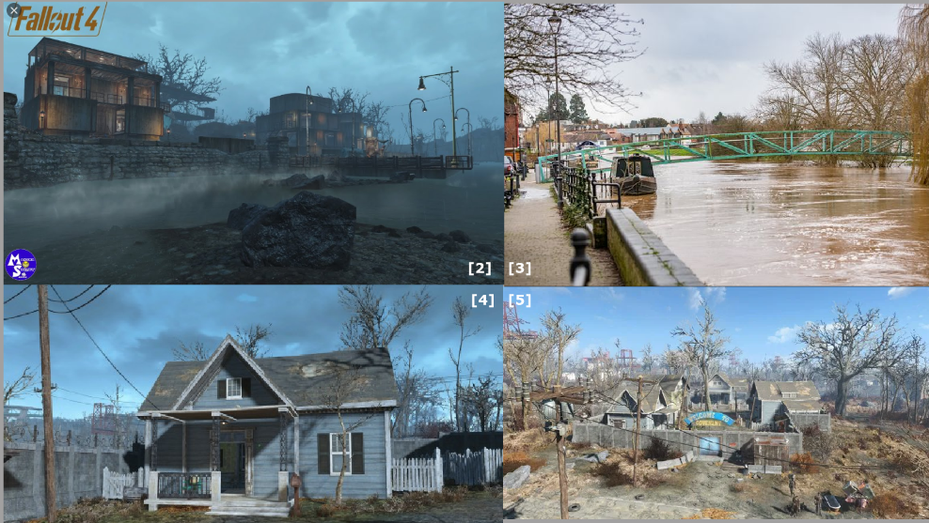
Figure 14: Contact Sheet 1 [2,3,4,5]

Hawker’s Gallery
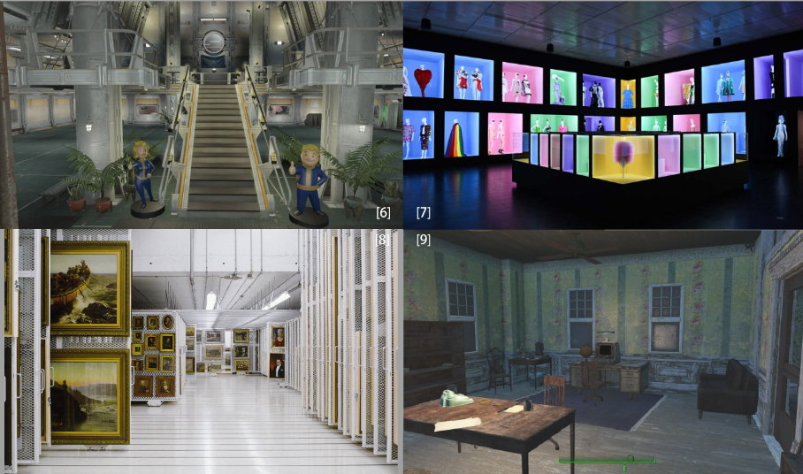
Figure 15: Contact Sheet 2 [6,7,8,9]

Characters/Dialog Flow

Character 1: Moss
Description | A middle-aged male human with red hair. As an ex-security lead, not as strong as imagined, but quite agile.
Background | The security lead of the Hawker Gallery in Alford. As a synth, he faked his own death with Valentine’s help to get rid of the Institute.
Goals/Motivation | He would like to maintain the peaceful life in Alford and hate the Institute.
Personality/Archetype | Straightforward, vengeful, rude
Relationships | - Valentine’s old friend  - The security lead of Hawker’s Gallery  - Nigel Hawker’s friend  - Betrayor of the Institute

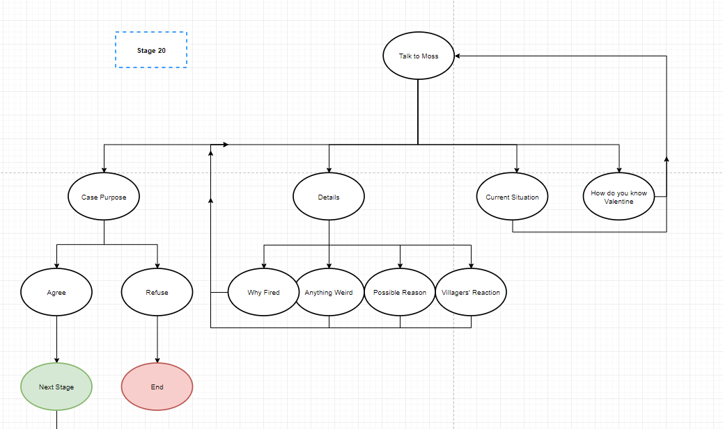
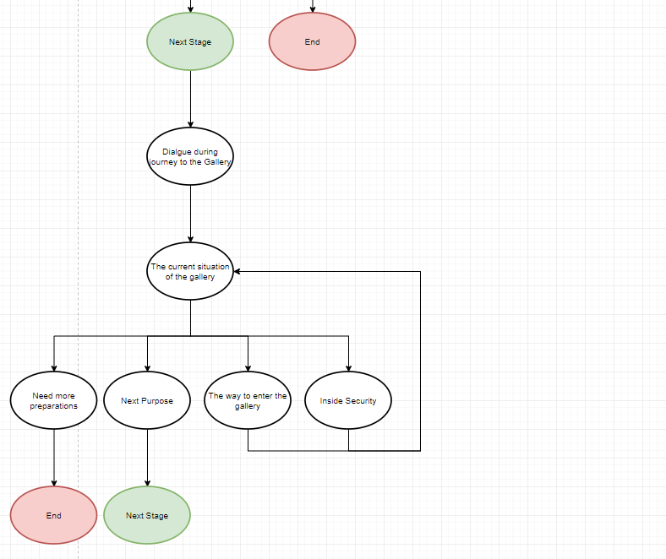
Figure 16: Dialog: Moss, Stage 20
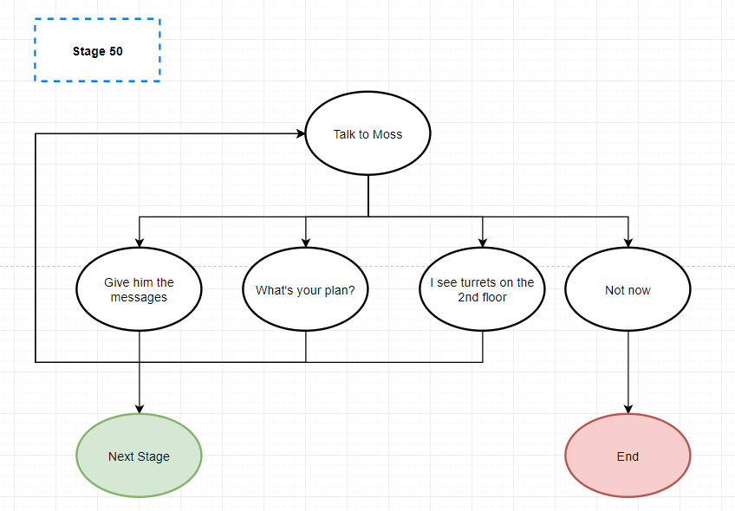
Figure 17: Dialog: Moss, Stage 50

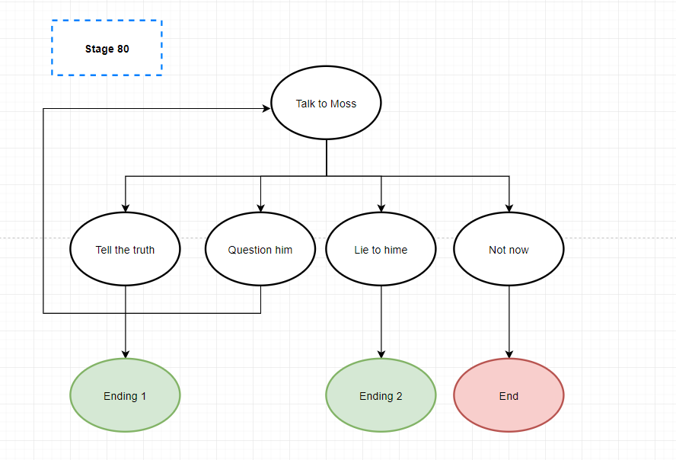
Figure 18: : Dialog: Moss, Stage 80

Character 2: Nigel Hawker
Description | An old wealthy man with grey hair. Most time he dressed in a suit and a hat.
Background | The richest man in Alford. He moved to the town 30 years ago and lives with his wife. His son also live in Alford, but in his own house.
Goals/Motivation | - Help his friend Laure hide from the Institute  - Protect his own family
Personality/Archetype | Gentle, respectful, tend to be in charge of everything
Relationships | - Moss’ friend  - Kenny Hawker’s father  - Laure’s old friend  - A respected old man in Alford

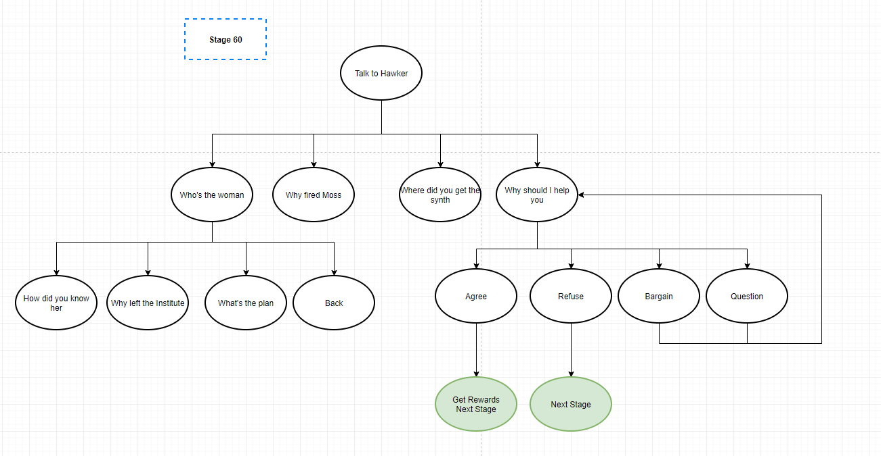
Figure 19: Dialog: Hawker, Stage 60

Character 3: Laure
Description | A middle-aged female human with short black hair. Dress in an old-fashioned dress which is borrowed from Mrs. Hawker.
Background | Laure spent most of her time at the Institute. She bought a famous painting from Mr. Hawker several years ago and became friends due to their common interest, paintings. She is unhappy with the current strategy of the Institute and finally decided to have a new life outside. She asked Mr. Hawker to help her to settle down in Alford and now is hiding in the gallery temporarily.
Goals/Motivation | - Start a new life in the outside world.  - Protect herself from the Institute.
Personality/Archetype | Rational, art lover
Relationships | - Mr. Hawker’s friend  - Escaper from the Institute

Character 4: Kenny Hawker
Description | A medium-built young man with brown hair.
Background | Live in an independent house in Alford, but quite near his father’s house. Moss says he acts weird these days.
Goals/Motivation | - Obey his father  - Protect his family
Personality/Archetype | Mild, submissive, a man of few words
Relationships | - Mr. Hawker’s only son

Character 5: Postman
Description | A postman in Commonwealth
Background | A common postman working in Commonwealth.
Goals/Motivation | - Deliver the letter as soon as possible
Personality/Archetype | Responsible, kind
Relationships | /

Risks
Map Label | Description/Mitigation | Type | Priority
8 | Wondering if the player will use this chance to observe the inner space situation | Conveyance | Middle
18,19 | Not sure if the AI packages can work naturally  How will the delay affect the NPC’s actions | Technical | Middle
20 | Wondering if the player will realize Mr. Hawker is walking towards the gallery | Conveyance | Low

Key Asset Needs
Description | Type | Priority
Complete House Modular Set | Modular Set | High
Furniture Modular Set | Modular Set | High
Museum/Gallery Modular Set | Modular Set | Middle
Street Decoration Modular Set | Modular Set | Middle
Natural Decoration Modular Set | Modular Set | Middle
3 Male Humans | NPC | High
2 Female Humans | NPC | High
Human Actions | NPC Action | Middle
Synth | Enemy | High
Laser Trap Set | Weapon Set | High
Standing/Hanging Turrets | Weapon Set | High
Terminal | Item | High
Lighting | Lighting | Middle

References
[Cover Image] https://www.treasurers.org/hub/treasurer-magazine/skeleton-closet
[1] https://www.ign.com/wikis/fallout-4/Red_Rocket_Truck_Stop
[2] https://www.youtube.com/watch?v=etq3aD1gS2U
[3] https://www.gloucestershirelive.co.uk/news/gloucester-news/river-levels-severn-wye-expected-3866676
[4] [5] [9] Screenshots from Fallout 4
[6] https://www.reddit.com/r/fo4/comments/bcrf6t/vault_88_part_2_gallery_in_comments/
[7] https://www.hollywoodreporter.com/news/metropolitan-museum-art-s-2019-costume-exhibit-spotlights-meanings-camp-1207839
[8] https://www.montel.com/en/applications/art-gallery-storage-systems

